London Borough of
Tower Hamlets

Highway Maintenance Transparency Report

2026/27



Contents
Highway Maintenance Transparency Report 1
Contents 2
A1 What do we maintain? 3
A2 Road condition 5
A3 Potholes and defects 7
A4 Spend and funding 9
A5 Our plans for this year 11
Technical Annex 13
B1 Funding and spending 14
B2 Maintenance activities 16
B3 Pothole repairs 17
B4 Highway structures 20
B5 Asset management 21
B6 Footways and cycleways 24
B7 Drainage 26
B8 Skills and training 27
B9 Resilience and adaptation 28
B10 Innovation 30
B11 Utility companies 32
B12 Highway contracts 33

A1 What do we maintain?
The London Borough of Tower Hamlets (Tower Hamlets) is London’s most densely populated borough, with over 15,700 residents per km², and experienced the fastest population growth of any borough between 2011 and 2021, increasing by 56,200 residents (22%). Historic streets, heritage features and globally significant commercial centres hosted within Tower Hamlets must be maintained whilst supporting the borough's evolving transport needs.
Under Section 41 of the Highways Act 1980, Tower Hamlets has a statutory duty to maintain this public highway network, ensuring it supports the safe movement of people and goods across the borough. The public highway network is not limited to roads alone, it includes additional asset types such as footways, cycleways, street lighting, drainage and highway structures.
 | 220km  carriageways  (roads) |  | 70km  cycleways |  | 10,848  drainage  gullies

 | 455km  footways  (pavements) |  | 10,033  street lighting columns |  | 82  highway structures

Key challenges
Maintaining this public highway network presents Tower Hamlets with several challenges, including:
- Network Usage: Almost 300,000 people work in Tower Hamlets and over 300,000 live in the borough, which together generate intensive highway use, higher than the demand and wear on assets expected when they were constructed.
- Growth and Development: The borough’s population is projected to grow by a further 17% by 2028, with increased building development also expected. The increase in new heavier electric buses and construction vehicles around developments places disproportionate wear on highway assets across the borough.
- Conservation Areas: Historic streets and heritage features often require bespoke maintenance solutions and traditional materials, increasing maintenance complexity.
- Climate: Frequent extreme weather worsens existing defects on the highway and places additional strain on the defined reactive maintenance response time to fix them within the defined times.

A2 Road condition
What do the condition bands mean?
Tower Hamlets undertakes biennial condition surveys of its carriageway network using Vaisala RoadAI to understand asset condition, calculate maintenance backlog and support investment decisions. Condition scores should be interpreted as follows:
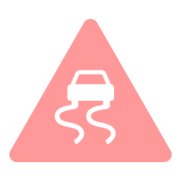
Green: These roads are in a good condition. No treatment is required but early-life preventative treatments (e.g. rejuvenation) can extend useful life.
Amber: These roads are in a fair condition. Preventative treatments can help tackle early-stage defects (e.g. cracking, fretting) and restore surface life.
Red: These roads are in a poor condition and have reached the end of their useful life. They are prioritised for structural maintenance (e.g. resurfacing).

From 2026/27 onwards, Tower Hamlets will comply with the new PAS2161 data standard for condition surveys, ensuring comparable results that enable benchmarking across England. The published official statistics for road condition include more detail about the methodology, timing and coverage of this data.

What is the condition of our roads?
Based on these regular condition surveys, Tower Hamlets monitors the condition of its carriageways over time to understand trends and determine the success of its investment. The following chart demonstrates the condition of classified (A and BC) and unclassified (U) roads over time. No data was approved for submission by the DfT in 2024 for B and C Roads, as no carriageway survey was undertaken in the financial years 2022/23 or 2023/24.

Figure 1: Condition of our roads by classification
Road conditions in Tower Hamlets have declined across all classifications between 2023 and 2025. Rising maintenance costs, which have outpaced available funding, together with increasing demands from new developments and EVs, have contributed to this trend. This reflects a growing maintenance backlog (total of roads in need of structural maintenance) from 20.5km in 2022/23 to 31.6km in 2024/25.

A3 Potholes and defects
What is a pothole?
Tower Hamlets defines a pothole as a depression or void in the road surface that poses a risk to road users. They typically form due to water ingress, freeze-thaw cycles and repeated traffic loading which cause failures and loss of material in the road surface. Potholes which meet investigatory thresholds are risk assessed to determine any appropriate action and repair timeline.
How are we tackling potholes?
In 2025/26, Tower Hamlets estimates that it repaired 511 potholes across its public highways through a combination of reactive and planned maintenance activities.
Reactive Maintenance:
Tower Hamlets takes a risk-based approach to tackling potholes and other highway defects. This policy is set out in the Tower Hamlets Highways Safety Inspection Manual, last updated in 2026, to align with industry guidance and best practice, such as the Code of Practice for Well-Managed Highway Infrastructure.
Figure 2: Potholes filled over time
Tower Hamlets undertakes regular risk-based inspections of every public highway in Tower Hamlets to identify defects posing a risk to highway users. Inspection frequencies vary by road hierarchy, which captures the function, usage and strategic importance of every road on the network based on features including public transport routes, traffic counts and proximity to critical services, such as hospitals. Defects are also identified through reports from the public, as detailed later in this section.
Where a defect meets the investigatory thresholds (as set out in the Technical Annex, below), a risk assessment is undertaken to determine the level of risk posed to highway users based on the likelihood of an incident occurring and the potential impact of that incident. The resulting risk factor identifies the seriousness of the defect and directly informs whether action is required and, if so, the response times. Defects posing a lower risk to highway users may not be actioned through reactive repairs and instead may be considered for works through planned (capital) maintenance.
Where it is safe and practical to do so, Tower Hamlets prioritises permanent repairs at the first visit to deliver a more durable outcome and minimise disruption to road users. However, temporary repairs may be necessary in many cases to ensure the highway is kept safe for users – this is usually required where a permanent repair cannot be delivered immediately, for example for emergency repairs or due to factors such as:
- Traffic management difficulties
- Inclement weather conditions
- Materials availability
- Utility constraints
- Coordination with wider Council plans
Planned Maintenance:
As well as reactive maintenance, Tower Hamlets delivers a capital planned maintenance programme to renew or extend the life of carriageways, tackling potholes with an approach that reduces long-term repair costs and improves network condition. This programme is described in Section A5.
How can the public report potholes / defects?
Members of the public can report potholes and other highway safety defects in Tower Hamlets by:
- Submitting an online report via the council website: Report a street problem
- Downloading and reporting via the ‘Love Your Neighbourhood’ app
- Calling the general council-wide out-of-hours service on 0207 364 7070
What happens after a pothole is reported?
Public reports or enquiries received relating to potholes and other highway defects are logged in the asset management system. Each report is subject to an initial desktop risk assessment to determine whether the defect is on council-maintained highway and understand the risk posed to highway users. If a reasonable risk is identified on council-maintained highway, the report is assigned an appropriate response time for investigation by a highway safety inspector. Defects outside of the Council’s remit are referred to the relevant parties. The highway inspector will undertake an on-site risk assessment in line with the approach described above.

A4 Spend and funding
How much do we spend on highways maintenance?
As mentioned in A1, funding pressures are a key challenge for Tower Hamlets. In 2025/26, Tower Hamlets spent £12.0m in total on maintaining public highways – a breakdown of how this is spent is provided below.
Table 1: Highway maintenance spend by asset class
Asset Class | 2024/25 | 2025/26 | 2026/27 (projected)
Carriageways | £2,435,880 | £4,176,181 | £785,922
Footways | £5,099,593 | £5,217,262 | £2,860,700
Structures | £305,374 | £394,389 | £400,000
Drainage | £505,698 | £551,651 | £585,000
Lighting | £3,735,257 | £1,696,949 | £1,278,839
Other | £0 | £0 | £0
Total | £12,081,802 | £12,036,432 | £5,910,461
Tower Hamlets has made significant cuts to its highway maintenance budget for 2026/27 compared to previous years. The projected spend for 2026/27 is £3.5m capital and £2.4m revenue. This is due to wider council funding constraints, representing a reduction of approximately 50% compared with 2025/26.
Tower Hamlets does not separate footways, carriageways and street furniture (benches, bins, bollards etc.) when accounting total spend. Reasonable estimates have been made to separate carriageways, but no meaningful estimate could be made to split footways and street furniture, so the sum of both spends is recorded as footways in the above table.

Where does our funding come from?
Tower Hamlets’ highway maintenance budgets are funded from various sources, as follows:
Table 2: Funding sources
Funding source | 2024/25 | 2025/26 | 2026/27 (projected)
DfT / Government | £137,000 | £448,790 | £1,796,000
Council / Third Party | £11,944,802 | £11,587,642 | £4,114,461
Total | £12,081,802 | £12,036,432 | £5,910,461
Tower Hamlets' highways maintenance activities are funded through a combination of central government grant and locally allocated council funding.
From 2026/27, the primary source of capital funding is the DfT highways maintenance block grant, allocated directly to local highway authorities. Since 2025/26, this funding has increased significantly as part of the Government's commitment to record levels of highways maintenance investment, with allocations confirmed through to 2029/30. Tower Hamlets will receive up to £5.8m over the next 3 years, of which £3.5m forms a guaranteed baseline element, and an additional £2.3m of incentive funding, subject to meeting certain criteria. This provides Tower Hamlets with greater funding certainty, shifting focus from reactive-focused regimes to long-term, planned and preventative maintenance.

A5 Our plans for this year
Highway maintenance plans for 2026/27
Tower Hamlets is continuing to deliver its various risk-based highways maintenance programmes in 2026/27, targeting investment where it provides the greatest benefit to the travelling public. The Council intends to deliver the following planned maintenance activities this year:
- Resurfacing approximately 0.6km of carriageways.
- Repaving approximately 6.4km of footways to ensure an appropriate level of service that promotes active travel, particularly walking and wheeling.
- Cleansing ~10,800 gullies to ensure people, properties and infrastructure are safe from flooding and the potential damage caused.
- Replacing 350 street lighting columns that have reached the end of their serviceable life.
Full list of planned works
Tower Hamlets is committed to being open and transparent about where and how it invests in the highway network. Sections of the following roads are earmarked for repaving (footways) or resurfacing (carriageways) in 2026/27:
Carriageway Schemes:
- Prestons Road
- Trafalgar Way
- Old Ford Road
Footway Schemes:
- Wheler Street
- Brick Lane
- Watts Grove
- Rope Walk Gardens
- Weyhill Road
- Buxton Street
- Uamvar Street
- Cahir Street
- Cobb Street
- Redchurch Street
- Solebay Street
- Old Ford Road
- St Stephens Road
- Approach Road
- Bromley Street
- Empson Street
- Joseph Street
- Coate Street
- East Ferry Road

How are decisions made on maintenance plans?
Tower Hamlets applies risk-based asset management principles to prioritise its capital investment for highway maintenance, ensuring the available funding is targeted where it will deliver the greatest community benefit. Every street in the borough is prioritised for maintenance based on:
- Condition: A street’s condition has the largest influence on its priority for maintenance, ensuring the focus is on keeping streets safe and serviceable.
- Use: The level of use on a street and its functionality are considered through the Network Hierarchy to ensure that investment is targeted where it benefits the most people.
- Spend: Recent reactive maintenance expenditure (e.g. filling potholes) is considered to identify opportunities to minimise less cost-effective reactive patching via planned works.
- Public Enquiries: Reports from members of the public are also considered to give communities the opportunity to provide input into maintenance plans.
Annual maintenance programmes are developed based on this prioritisation, with schemes taken forward following coordination with other highway works – these may be by other council departments or third parties – to avoid early failures, repeat repairs and to minimise disruption.

Technical Annex

B1 Funding and spending
Further detail on the funding for highway maintenance and how this is spent is set out below.
Capital Funding
Table 3: Capital funding allocation sources by year
 | Funding sources | 2024/25 | 2025/26 | 2026/27*
DfT | Highway maintenance capital allocation | £137,000 | £448,790 | £1,796,000
DfT | Other capital allocated to highway maintenance | £0 | £0 | £0
 | Other government capital allocated to highway maintenance | £0 | £0 | £0
 | Other capital allocated to highway maintenance | £8,138,783 | £7,911,347 | £1,684,639
 | Total capital funding allocated for highway maintenance | £8,275,783 | £8,360,137 | £3,480,639
The capital figure for 2024/25 is significantly increased compared to the 2025 report. For street lighting, this is due to the addition of staff capitalisation costs, improvements under public realm schemes and funding in relation to upgrading remote network management capabilities. These factors combined to roughly £800,000. For carriageways and footways, traffic management and staff capitalisation costs were included in 2026 having been omitted in 2025, these totalled to £400,000.
Spending
Tower Hamlets Council confirms that it understands the answers in this section relate to compliance under the 2026/27 local highway maintenance incentive funding requirements. | Yes
Table 4: Total capital and revenue highway maintenance spend
Funding stream | 2024/25 | 2025/26 | 2026/27*
Total capital spend | £8,275,783 | £8,360,137 | £3,480,639
Total revenue spend | £3,806,019 | £3,676,295 | £2,429,822
Total spend | £12,081,802 | £12,036,432 | £5,910,461

Carriageway maintenance spend
Table 5: Carriageway spend by maintenance type
Maintenance type | 2025/26 |  | 2026/27*
 | Capital | Revenue | Capital | Revenue
Total planned maintenance | £3,394,222 | £0 | £350,000 | £0
Preventative | £0 | £0 | £0 | £0
Structural | £3,394,222 | £0 | £350,000 | £0
Patching | £0 | £0 | £0 | £0
Total reactive maintenance | £0 | £445,171 | £0 | £100,000
Temporary repairs | £0 | £111,293 | £0 | £25,000
Permanent repairs | £0 | £333,878 | £0 | £75,000
Other carriageway spend | £0 | £336,789 | £0 | £335,921
Total carriageway spend | £3,394,222 | £781,960 | £350,000 | £435,921
Other carriageway spend includes provision for winter service and routine safety inspections, based on the estimated splits from the overall carriageway and footway budget.

B2 Maintenance activities
Table 6: Road resurfacing and surface treatment quantities
FY | Planned Maintenance |  |  | Reactive Maintenance
 | Preventative | Structural | Patching | Permanent | Temporary
2025/26 | 0 km | 6.5 km | 0 m² | No Data Held | No Data Held
2026/27* | 0 km | 0.6 km | 0 m² | N/A | N/A

Does Table 6 reflect all carriageway-related road surface treatments and repair activities? If no, see further information on any other types of treatments delivered and their extent. | Yes

B3 Pothole repairs
This section sets out how Tower Hamlets identifies and repairs potholes and other defects in carriageways, and how this activity fits within the wider maintenance approach.
Intervention criteria
Tower Hamlets uses risk-based investigatory levels to determine when to risk assess potholes or other carriageway defect and define an appropriate response. The following table sets out Tower Hamlets’ investigatory thresholds for different defect types.
Table 7: Defect categories and investigatory levels
Defect Type | Location | Response time | Investigatory Threshold
Pothole | Carriageway | The risk associated with a defect is based on its size and location, it’s then assigned an appropriate priority and response time. | >40mm
 | Cycle Lane |  | >25mm
 | Footway & Crossing Point
If a pothole or other highway defect meets this investigatory threshold, the safety inspector will undertake a risk assessment using the following risk matrix – this assessment will consider the size, location and level of usage of the area to determine a risk score.
Table 8: Risk matrix
Impact | Probability / Likelihood
 | Very Low | Low | Medium | High
Negligible | 1 | 2 | 3 | 4
Low | 2 | 4 | 6 | 8
Noticeable | 3 | 6 | 9 | 12
High | 4 | 8 | 12 | 16
Table 9: Defect priority response times
Priority Category | Response Time
Priority 1 | 2 hours: Attend to and make safe within 2 hours
Priority 2 | 24 hours: Attend to and repair within 24 hours
Priority 3 | 5 days: Attend to and repair within 5 days
Priority 4 | Monitor, or attend to and repair within 28 days

Pothole maintenance
Description | Potholes
Number of potholes filled in 2025/26 | 511
of which, Tower Hamlets estimates were resolved using the following approaches:
Planned repair / patching | No data held
Planned structural | No data held
Temporary reactive repairs | 364
Permanent reactive repairs | 147
CAUTION FOR READERS: Authorities have different criteria for identifying potholes and different methodologies for counting how many they have filled or resolved. Summing the figures in the above table across authorities will therefore not provide a reliable estimate of the total number of potholes filled across England.
Prices of pothole interventions
Unit cost (permanent pothole repair) | £200 | Unit cost (temporary pothole repair) | £116
Given the variety in pothole severity and specification of repair (based on traffic volume and heavy vehicle loading), it is difficult to provide a single answer for the price to repair a pothole. These are therefore indicative averages based on all repairs.
Defect repair quality
Do you set requirements to those delivering repairs about the longevity of both a) planned repairs/patching, and b) reactive repairs using permanent methods? | Yes
If yes, do you base your material and process specifications on these longevity requirements? | Yes
Do you regularly monitor the appropriateness of the carriageway interventions chosen by your workforce or contractor and the quality of work delivered? | Yes
If yes, do you systematically record information about expected and delivered longevity of repairs? | Yes
Tower Hamlets sets requirements for the longevity of all carriageway repairs using permanent methods, which are reflected in the Council’s materials matrix and contract specifications, namely the Schedule of Rates, which defines materials, methods and price of any highway maintenance activity carried out by the term maintenance contractor, JB Riney. Contractor performance is measured against agreed KPIs, using routine assessments from both Tower Hamlets’ highway engineers and safety inspectors.
Public reporting system for defects and other issues
Are defect reports from the public routinely used as an input into maintenance planning and inspection regimes? | Yes
Do you inform users about the outcomes from their feedback, including when no action is to be taken? | No
Tower Hamlets considers the volume of public enquiries in its annual carriageway and footway works programmes, using this as a weighting factor to ensure concerns from residents are appropriately captured in prioritising which roads are considered for maintenance.
Where jobs have been addressed before a public report is received, and details of the action taken are known, Tower Hamlets will confirm that the job has been addressed. In most other cases, enquiry responses affirm that the issue will be investigated and addressed as appropriate, but it is not practical to provide details for every enquiry following any actions taken.

B4 Highway structures
Tower Hamlets maintains 82 highway structures, for which it carries out routine inspections in line with Standards for Highways requirements. When these inspections identify an issue, Tower Hamlets will generally deliver any necessary repairs on a reactive basis, unless the scale of the issue requires a more long-term, planned approach.
Description | No.
Number of highway structures maintained by Tower Hamlets | 82
Highway structures with interim measures in accordance with CS470 | 0
General Inspections (GI)
Number of structures due a GI in 2025/26 in accordance with CS450 | 16
Number of GIs carried out in 2025/26 | 16
Principal Inspections (PI)
Number of structures due a PI in 2025/26 in accordance with CS450 | 5
Number of PIs carried out in 2025/26 | 5

B5 Asset management
This section focuses on asset management practices that underpin how the authority plans, prioritises and delivers highways maintenance. It is intended to provide confidence that decisions are evidence-led, risk-based and aligned to whole-life value, in line with the Code of Practice for Well-Managed Highways Infrastructure.
Asset management strategy and policy
Tower Hamlets Council confirms that it understands the answers in this section relate to compliance under the 2026/27 local highway maintenance incentive funding requirements. | Yes
Tower Hamlets has adopted its Highway Asset Management Plan (HAMP) to set out its strategic framework for how it plans, prioritises and invests in maintenance across its public highway infrastructure. It sets out various aspects ranging from performance objectives and financial strategies to lifecycle plans and sustainability commitments.
Tower Hamlets’ Highway Asset Management Policy and Strategy can be found on the council website.
Tower Hamlets’ HAMP was last updated in: | Oct 2025
The current HAMP was published in October 2025 following approval by Head of Highways, Traffic, Transportation and Parking in October 2025.
Asset data
Tower Hamlets maintains asset inventory and condition data across its key highway asset groups to support evidence-led maintenance planning and investment decisions. The table below sets out the current status of inventory and condition data held for each key asset type.
Table 12: Information on quality of highway asset data held
Asset | Asset inventory | Condition data
Carriageways | Full | Full
Footways and cycleways | Full | Full
Highway structures | Full | Full
Drainage assets | Full | Full
Street lighting | Full | Full
Traffic signals | TfL maintain traffic signals across London
Asset data integration and management
Asset inventory and condition data for key highway assets is primarily managed via:
Discrete spreadsheets or documents held by individual teams
Multiple digital platforms with limited integration
Single digital platform or a set of connected platforms used across service | Yes
Other
Tower Hamlets’ highway officers, inspectors and term maintenance contractor are responsible for collecting data on highway assets and updating the asset inventory as and when things change. An Information Management Manual and asset inventory review are planned to ensure that stored information remains correct, useful and up to date.
Tower Hamlets' highway asset data is primarily managed through Causeway Alloy. This system holds asset inventory, inspection records, condition data and works orders.
Highway structures are managed through BridgeStation, as is standard in London under the pan-London approach set out via the London Bridge Engineers Group (LoBEG).
To record other asset data, EzyTreev is used for trees and KaarbonTech for drainage.
Lifecycle planning and investment decision making
This section sets out how Tower Hamlets uses lifecycle planning to inform maintenance investment decisions, rather than relying solely on reactive demand or short-term pressures.
Do you use lifecycle plans for carriageways to support investment decisions? | Yes
Do you use lifecycle plans for footways to support investment decisions? | Yes
Do you use lifecycle plans for structures to support investment decisions? | Yes
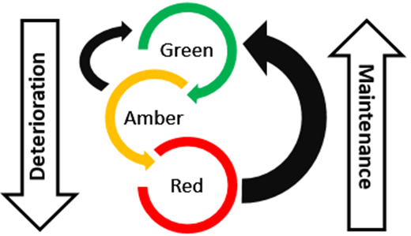
Tower Hamlets uses lifecycle planning to forecast future asset condition, considering the balance of uplift and deterioration, as shown in Figure 9. Tower Hamlets forecasts asset condition and backlog with differing funding requirements to inform investment decisions. This approach is captured in the HAMP, as well as in the lifecycle investment planning exercise carried out in 2024.
Figure 3: Lifecycle planning and deterioration cycle
Using lifecycle planning, Tower Hamlets has developed strategic maintenance investment plans for various asset groups – this ensures that the right intervention is made at the right time to maximise asset life, ensure cost-effectiveness and achieve best value from available funding.
Performance and continuous improvement
This section sets out how the Council monitors the effectiveness of our asset management approach and use performance information to inform ongoing investment and prioritisation decisions.
Do you have a defined set of key performance indicators (KPIs) to monitor the outcomes of your highways asset management approach? | Yes
Are these KPIs reviewed on a regular basis (at least annually)? | Yes
Are KPI trends used to inform maintenance planning, prioritisation or changes to forward programmes or investment decisions? | Yes
Performance monitoring and management is important to ensure the level of service is maintained. Tower Hamlets use Key Performance Indicators (KPIs) to measure, monitor and ensure that the level of service is maintained across all assets. KPIs also inform other asset management activities, such as maintenance and investment planning, indicating whether progress is on track against objectives and highlighting areas for improvement. KPIs also support decisions on prioritising interventions, efficient allocation of resources, and determining the effectiveness of maintenance strategies, regimes and interventions. These KPIs are monitored and reported on an annual basis.
Tower Hamlets has a Performance Management Framework, located in the HAMP, that covers the strategic KPIs measured by the Council, and the targets for each. Internal KPIs are reviewed at least annually to understand performance trends and inform funding priorities and maintenance programmes, directing investment and resources where they are needed most.
Tower Hamlets is committed to continuous improvement and benchmarking its performance through collaboration with various industry bodies, primarily the London Highways Engineer Group (LoHEG) as well as LCRIG and UKRLG.

B6 Footways and cycleways
Tower Hamlets maintains an extensive network of footways and cycleways that support active travel across the borough. The authority adopts a risk-based approach, combining reactive repairs with planned maintenance to keep walking and cycling infrastructure safe, accessible and serviceable.
Do you have a defined footway hierarchy (e.g. based on footway function and usage levels) that underpins a risk‑based approach to inspection frequencies and maintenance programmes? | Yes
Are priority footways and cycleways included in your winter service (e.g. gritting or snow clearance), and in a routine programme for keeping them clear of overgrown vegetation and debris (e.g. sweeping, cutting back)? | No
Tower Hamlets’ footway and cycleway maintenance programme is defined in line with the Well-Managed Highways Infrastructure: A Code of Practice, by categorising streets by function, usage and relative priority. The footway and cycleway hierarchy structure can be seen in the table below:
Category | Functionality Factor | Functionality Definition
A | Prestige | High Profile
B | Very High Pedestrian Volume, Health Services, Major Traffic Generators, Major Bus Route | Local knowledge, Hospitals, Schools with >1,500 pupils, Town Centres, Stations with >10 million annual passengers, 30 or more buses per hour
C | High Pedestrian Volume  Medium Traffic Generators  High Cyclist Volume  Medium Bus Route | Local knowledge  Schools with 1,000-1,500 pupils, Retail Areas & Markets, Stations with 1-10m annual passengers  Defined Cycleways  15-30 buses per hour
D | Medium Pedestrian Volume  Medium Traffic Generators  Medium Cyclist Volume  Minor Bus Route  Emergency Services | Local Knowledge  Schools with <999 pupils, Industrial Areas, Museums, streets on a Marathon Route, Stations with <1m annual passengers  Other cycle routes  <15 buses per hour  Police Stations, Fire Stations
E | Low Pedestrian Volume  No Traffic Generator | Local knowledge  None of the above
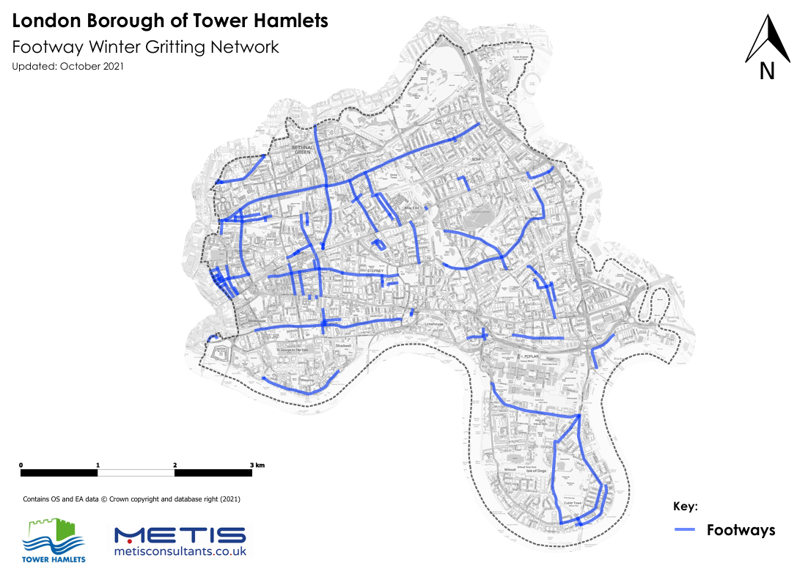
When snow falls, making it too slippery to sweep, Tower Hamlets’ road sweepers will salt footways instead. This regime prioritises key strategic access routes, for example outside hospitals, schools and public transport hubs. Tower Hamlets does not operate a dedicated routine vegetation or debris clearance regime, rather it identifies issues through it’s routine highway safety inspections, which are then dealt with on an ad-hoc basis.
Figure 4: Footway winter gritting network
Asset | Structural | Preventative
Footways | 6.4 km | 0 km
Cycleways | 0 km | 0 km
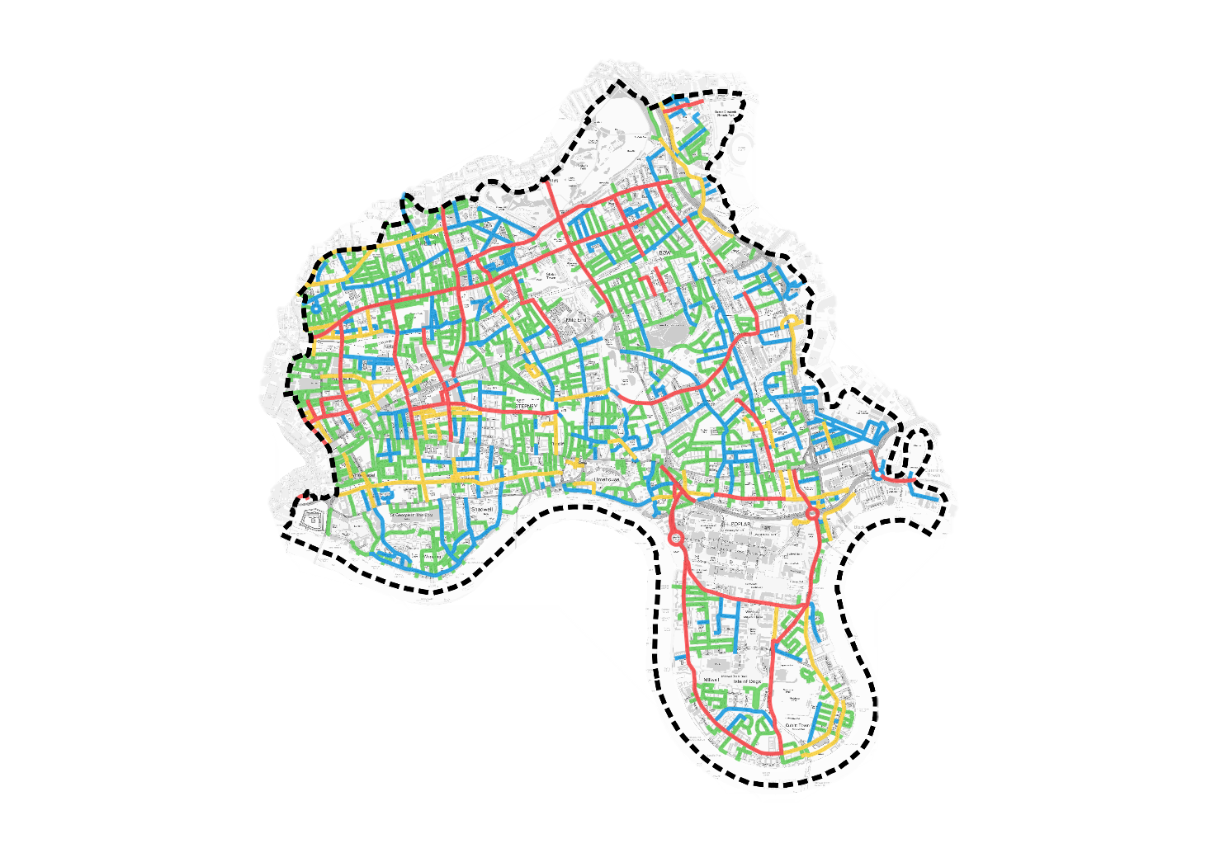
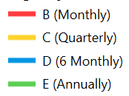
Tower Hamlets' footway maintenance programme is defined in line with the Code of Practice for Well-Managed Highways Infrastructure by categorising streets by function, usage and relative priority. It defines the required frequencies of highway safety inspections for each road on the network, and is also considered as a weighting factor on the works programme, combined with other factors such as condition, reactive job frequency and public enquiries to produce a prioritised programme of maintenance.
Figure 5: Network Hierarchy classifications

B7 Drainage
Effective drainage maintenance is essential to mitigating the risk of flooding, ensuring that the public highway network is resilient and durable, and properties are safe from damage.
Table 13: Drainage maintenance expenditure by approach

Tower Hamlets manages its highway drainage network using a risk-based approach that combines planned cyclical cleansing with reactive intervention, using asset data and maintenance records to target resources where they are most needed.
Does your authority utilise a digital drainage management platform, covering asset inventory, inspection history, sensor data, and risk scoring? | Yes
Do you maintain a record of locations where drainage issues are known to cause or contribute to carriageway deterioration or surface water ponding? | No
Do you utilise smart sensors or other remote monitoring technologies to monitor performance of your drainage assets? | No
Tower Hamlets manages its drainage assets using KaarbonTech which provides a centralised repository for asset inventory, inspection records, defect information and maintenance history. In conjunction with a Drainage Management Plan, Tower Hamlets has created a risk-based drainage maintenance hierarchy and programme, which defines the frequency of routine cleansing and prioritisation of reactive maintenance based on risk factors including leaf fall and areas with higher risk of surface water flooding.
Tower Hamlets is a densely populated borough and therefore the primary concern from surface water flooding is the risk it poses to residents and private property. As such, Tower Hamlets maintains records of known surface water flooding issues, but not specifically in reference to carriageway deterioration. In most cases, maintenance carried out to address flooding of private property will also address carriageway deterioration concerns.
Tower Hamlets is planning to install smart gully sensors to automatically trigger when high water levels are detected in gullies. Trials for these sensors are planned from 2027/28.

B8 Skills and training
Do you have an up-to-date training and development plan for those responsible for highways asset management in your authority? | Yes
Do you or your main highways contractors support professional development through a recognised professional training scheme? | Yes
Does your authority contribute towards the cost of professional membership or professional development required for relevant highways roles? | Yes
Do you employ a professionally qualified engineer (e.g. Chartered Engineer or equivalent competence) responsible for the management of highway structures? | Yes
Does your authority define competence requirements for key highways asset management roles and take steps to address any identified gaps? | Yes
Do you or your main contractors support early career development in your local area (e.g. apprentice schemes, traineeships or pre-apprenticeship programmes, sponsored qualifications (e.g. HNC/HND, degree, MSc), graduate schemes etc.) | Yes
Tower Hamlets has access to professionally qualified engineers and inspectors including Chartered Engineers and NRSWA supervisors, either through in-house resources or contracted technical support arrangements. These individuals provide oversight and technical leadership for the management of highway infrastructure and associated assets, including highway structures.
Tower Hamlets has clear documentation outlining the competencies required for different roles in the department and the training required to achieve them. The training is delivered as structured classroom-based learning with an approved supplier, learning from peers through continual professional development and experience carrying out the role. As an example, Tower Hamlets staff have attended recent training organised by the term maintenance contractor to develop knowledge and understanding of low-carbon and preventative treatment options and where they would be most effective. Annual staff appraisals are undertaken to ensure training is approriate as well as annual peer review workshops to ensure consistency across the team.
Tower Hamlets provides apprenticeship schemes within the Highways, Traffic, Transportation and Parking team, where apprentices rotate around the different service areas to gain a broad level of experience. Tower Hamlets also attends job fairs and advertises roles as part of the Council’s commitment to social value. Tower Hamlets’ contractors run apprenticeship schemes of their own as well.

B9 Resilience and adaptation
Adapting roads to withstand climate pressures
Climate and environmental factors, such as heavy rainfall, prolonged heat and freeze-thaw cycles, are integral to effective highways asset management, as they influence asset performance, deterioration rates and long-term resilience. Understanding both the impacts of a changing climate and the carbon implications of maintenance activities supports better decision-making helps Tower Hamlets to optimise durability, manage risk and deliver best whole life value from all assets.
Have you updated your asset management policy and strategy to reflect the increased probability of extreme-weather and/or geohazards now and in the future? | Yes
Have you identified your resilient network and agreed this with senior decision-makers? | Yes
If yes, when was this last updated? | 2025
Have you identified locations that are repeatedly affected by extreme weather (e.g. flooding, heat damage, storms)? | Yes
Have you measured and benchmarked the greenhouse gas emissions from your highways maintenance service using a recognised industry standard? Or do you have arrangements in place to do so (e.g. ADEPT Carbon Leadership Programme)? | Yes
Have you formally engaged with the ADEPT Live Labs 2 Programme to understand what lessons your authority can utilise to increase the efficiency of your operations and support decarbonisation efforts? | No
Tower Hamlets responds to most extreme-weather-induced incidents reactively. However, the Council maintains an awareness of 5 critical drainage areas which are considered high priority for maintenance in order to be proactive against extreme rainfall events.
Tower Hamlets created the highways Carbon Management Strategy in 2022, following which the Council carried out a baselining exercise to understand embodied CO2 in 2024 across all assets except structures. This exercise was used to create the highways Carbon Management Plan, which identifies measures the council can implement to lower net carbon emissions and a roadmap for doing so.

Tower Hamlets has engaged in the following activities to improve heat resilience across the borough:
Targeted drainage upgrades or maintenance | Yes
Natural flood management / SuDS | Yes
Targeted slope / ground stability / landslip mitigation | No
Heat resilient materials or surface treatments | No
Tree planting / shading for heat management | Yes
Other | No
None of the above | No
Tower Hamlets actively manages climate-related risks to the highway network through a combination of planned adaptation measures, emergency planning and cross-service collaboration.
Tower Hamlets has taken several steps to reduce its environmental impacts such as upgrading all luminaires to LED technology, adopting an adaptive lighting strategy, using warm-mix asphalt resurfacing specifications and trialling innovative treatments (e.g. recycled rubber-mix surfacing).
Tower Hamlets has emergency plans for climate events that impact highway infrastructure, as included in the Local Flood Risk Management Strategy (LFRMS), Surface Water Management Plan (SWMP) and the Winter Service Plan (WSP).
Tower Hamlets is committed to providing resilience by recognising and protecting key links as defined in the Resilient Network and having the appropriate emergency plans in place. The Resilient Network represents a collection of strategic roads that are essential for the continuity of economic activity and access to emergency or essential services such as schools, hospitals and shops. It has been defined in coordination with other London boroughs via LoTAG.
In 2025 and 2026, Tower Hamlets produced a SuDS Guidance Document and undertook an opportunity mapping exercise to identify suitable and effective potential SuDS locations. Similarly, as part of the Public Highway Tree Planting Programme, Tower Hamlets plans to plant another 137 trees, which will provide additional shelter and heat relief to pedestrians.

B10 Innovation
Tower Hamlets is committed to the continuous improvement of its highways maintenance service planning and delivery, embracing innovative materials, techniques, technologies and processes where these can improve network performance, reduce costs, lower carbon emissions or minimise disruption to road users.
Do your procurement and contracting approaches encourage and reward innovative practice? | Yes
Can you demonstrate that innovative materials and practices are regularly reviewed and, where appropriate, integrated into business-as-usual operations? | Yes
If you have conducted innovation trials, have you shared the findings of these publicly or with professional networks? | Yes
Tower Hamlets works with its contractors and supply chain to explore and implement innovative maintenance techniques and materials, seeking to improve asset performance and value for money while reducing the carbon impact of maintenance activities.
In 2026, the Council is undertaking ride quality analysis from connected vehicle data. Applying this ride quality data will complement the visual condition surveys undertaken which excel at collecting data on visible defects but are less accurate when used alone to measure less visible defects, such as undulating profiles and subsidence issues for which the ride quality analysis is more effective.
Tower Hamlets is investigating the development of a centralised digital model that provides a more aligned and holistic view of its highway and transport network. This system will strengthen the evidence base for decision making and progress monitoring, allowing Tower Hamlets to understand its performance over time and prioritise investment efficiently.
Tower Hamlets is trialling fibre-reinforced paving slabs where vehicle overrun is expected to reduce wheel loading damage on footways. This is being trialled on permitted streets in various areas across the borough.
Examples of innovation adopted
- Adaptive Street Lighting – Tower Hamlets has undertaken a review of streets, considering factors such as cycle routes, public services (hospitals, schools etc.), town centres and traffic to determine a street lighting risk hierarchy. Various suitable streets were identified in trials for lower lighting levels in 2023/24. Following the completion of Central Management System (CMS) integration across the network in 2025, Tower Hamlets have begun a phased implementation of adaptive lighting, which has already begun to reduce the cost and carbon resulting from electricity for lighting, while maintaining safety standards in accordance with British Standards. Tower Hamlets is also investigating the potential to integrate column-attached traffic count sensors with the CMS network, in order to gain live and synchronised network insights through the same system.
- AISIN Connected Vehicle Data – In 2025, Tower Hamlets used AISIN RoadTrace connected vehicle data to identify areas on the network where high speeds and harsh braking were prevalent. This data was fed into a wider road safety scoring system to identify priority locations for safety improvement schemes across the borough, resulting in a road safety action plan. This provided a cost-effective means of collecting this information, compared to alternative methods.

B11 Utility companies
Utility companies and highway authorities carry out a significant volume of works on the public highway each year, with a direct impact on network availability, surface condition and the experience of road users. Tower Hamlets works to minimise the disruption caused by these activities through monitoring, enforcement and coordination with utility companies and other stakeholders.
Work to reduce disruption to road users
Do you routinely monitor and enforce utility works quality as part of your streetworks management? | Yes
Have you undertaken a senior‑endorsed assessment of whether a lane rental scheme would be suitable for your area? | Yes
Do you seek input from utility companies when determining your highways maintenance programme to help reduce disruption? | Yes
Have you conducted and published a permit scheme evaluation within the last three years? | Yes
Have you conducted a traffic sensitive review in the last three years? | Yes
Tower Hamlets operates a permit scheme and actively monitors utility works through inspections, site checks, defect identification and enforcement action where appropriate. Utility and highway works are coordinated to minimise disruption, with regular engagement with utility companies through planned coordination meetings and the permit process.
Streetworks inspectors are trained in NRSWA regulations and best practice. Inspectors check elements of third-party works such as traffic management, quality of materials and methods applied during works, then inspect quality of the reinstatement as well as other requirements such as site clearance once the work is completed. Where non-compliance is identified, inspectors issue non-compliance notices to the third party and ensure that any issues are appropriately addressed and resolved.
Tower Hamlets carried out a suitability assessment for Lane Rental with support from Transport for London in 2025/26. Statutory trials are now set to commence in October 2026, before full implementation in January 2027. Once implemented, the Lane Rental Scheme will provide a direct financial incentive for utility companies and contractors to complete works more quickly, at less disruptive times and using more innovative construction methods. By charging for occupation of the most congested parts of the network during busy periods, Lane Rental will encourage better planning and coordination of works, reduce the duration of road occupations and help protect the condition of the highway surface from the cumulative impact of repeated openings. More information about Tower Hamlets is provided in the scheme document: London Borough of Tower Hamlets Lane Rental Scheme | 2026.

B12 Highway contracts
Managing contracts effectively
Does your authority retain in-house technical capability to independently assess maintenance interventions proposed by contractors? | Yes
Do you routinely analyse actual unit costs (for example £/m² of road surface treatments, or £/pothole repair) for core highways maintenance activities delivered under contract and compare them against benchmarks or historic performance? | Yes
Do you have defined KPIs for your highways maintenance contract(s), and are they actively monitored by your authority to manage performance? | Yes
If reactive pothole repairs are delivered by a contractor, do your contracting arrangements incentivise single‑visit permanent repairs where it is safe and appropriate to do so? | Yes
With the Highways Group Manager role, Tower Hamlets maintains in-house technical capability and experience to assess intervention materials and approaches. Interventions carried out by the term maintenance contractor are defined in Tower Hamlets’ Schedule of Rates, which defines specified methods, materials and prices of all maintenance work. Unit cost changes are reviewed against inflation and indexation figures to understand the volume of works that can be delivered within the capital and revenue maintenance budgets, from which Tower Hamlets makes appropriate adjustments to maintenance plans and strategy.
Contractor KPIs are monitored through contractor reporting and auditing as part of monthly contract meetings.
Tower Hamlets uses risk assessments from safety inspectors. High risk defects must be made safe within a short period of time, so the appropriate action may be to make the defect safe and plan a later repair, or for a temporary patch to be used to mitigate the hazard. When a defect is assessed as posing lower risk, the response time is of sufficient length to plan a permanent repair on a single visit.

