Appendix 3

Vehicle Incident Reporting and
Investigation Procedure

Accident reporting procedure

Line manager /Supervisor should investigate all accidents Reported by their drivers or by external sources against vehicles under their control.

A “LBTH Motor Claim Form”, that could be found below, must be fully completed as soon as possible and forwarded to the Fleet Department at fleet@towerhamlets.gov.uk together with all related evidence including photographs and any other documentation.

The Line Manager and Supervisor must ensure that their drivers are aware of the procedure to be followed in the event of their being involved in a road traffic accident.

In the event of the accident drivers should:

- Stop and investigate if any person involved in the accident or incident is injured and arrange for help
- Remain Calm, do not argue or show aggression
- Call the Police if:
- the accident resulted in injuries to any person or animal or serious damage to vehicle or property
- in driver’s opinion, the other driver was driving recklessly or under the influence of alcohol or drugs
- Third Party will not provide their name, address, vehicle and insurance details.
- Report to the Police asap within 24hrs if Third Party is not available and note the reference number
- Contact their Supervisor/Line Manager and report the accident as soon as practically possible.
- Do not ignore the possibility of the stationary vehicle(s) creating a hazard to other road users. Where necessary, arrange for other drivers to be warned in sufficient time for them to take appropriate action if safe to do so. If the Council vehicle is equipped with hazard warning lights, amber beacons or is carrying traffic cones, these should be used to help warn all approaching traffic.
- Never leave the scene of an accident were someone has been injured, unless instructed to do so by a relevant authority.
- Use Councils ‘Bump Card’ to capture necessary information.
- Obtain all the information required to complete an accident report form, including:
- details of any damage, injuries, witnesses, etc
- the insurance details and names and addresses of all vehicle occupants and vehicle or property
- the names and addresses of any independent witnesses to the accident
- If a camera is available take photographs of the vehicles, area and the damage.
- Where possible draw a sketch of the accident scene noting vehicle and person positions and other significant details (speed limits, signs, etc.)
- Not admit liability or blame, either verbally or in writing, or make any offer of promise of payment.
- Provide own
- name and address.
- the registration number of your vehicle,
- the address of your depot
- insurance details incl. policy number (can be found on the Bump Card);
- Report damage to Council’s vehicle by recording it on a vehicle defect report and report it to their Supervisor/Line Manager as soon as possible. If in doubt about safety or the legal use of a vehicle, the vehicle must not be driven until authorisation is received.

Please note that if a driver refuses to give the statutory information to anyone with reasonable grounds for requiring it at the scene of an accident, the driver is guilty of an offence even if they later report the accident to the Police.

If legal proceedings are taken against the driver of a Council vehicle, the matter must be immediately communicated to drivers’ Supervisor/Line Manager and the Fleet Department.

All communications received from insurance companies, or third parties must be immediately forwarded to the Fleet Department and must not be answered or acknowledged in any way by the driver, Supervisor or Line Manager.

In case of the serious accident resulted in injuries and/or serious damage to either vehicle or property The Health & Safety Manager is also to be advised.

For the avoidance of doubt when deciding who should fill in an accident form, the driver last in charge of the vehicle shall complete the forms in full and provide all information, except in exceptional circumstances, in which case the responsibility transfers to the driver’s supervisor / line manager.

The Council Fleet Department will arrange for vehicle repair estimates, actual repairs and monitor recovery of costs when applicable.

All vehicle insurance matters will be referred to the Council’s Vehicle Insurer by Fleet Department and Councils insurer may be required to speak to either driver or their manager, so full cooperation from the vehicle Users is required.

Drivers must report any accident and vehicle damage to a Council owned, leased or hired vehicle at the first available opportunity to their Supervisor/Line Manager and fully cooperate in the investigation.

A LBTH Motor Claim Form to be completed in full on return to depot.

An incident investigation interview should take place between the driver and their line manager as soon as possible (preferably within 24-48 hours but certainly within a week) and findings to be forwarded to the Fleet Department so it could be stored on the system and results could be incorporated into an incident reporting system.

An incident investigation interview should include the following:
- Discussion, identification and recording of all facts to understand the full dynamics of the collision scenario and collision mechanism.
- Identification and listing of all possible contributory causes.
- Using the list of possible contributory causes to identify the underlying root cause.
- Ensuring that the driver is fully aware of the true fiscal impact the incident has had on the organisation
- Figuratively, re-running the collision mechanism and asking the driver to suggest what they might do differently to avoid the incident, or reduce the severity of outcome
- Recording and forwarding significant findings to the company central incident reporting/investigation system
- Communicating this to share "lessons learned" without apportioning blame.

Bump Card

All drivers who drive Council owned, leased or hired vehicles should carry a “Bump Card” with them when on road.

The Bump Card has been designed to assist drivers in complying with their legal responsibilities in the event of a road traffic accident. It should help drivers ensure that they don't forget to obtain vital information at the scene, even if they are suffering from shock.

The detachable Part B of the card is pre-filled with Council insurance details and contact information. It should be given to the Third Party involved in the accident to provide them with vital information.

The User Department can request the cards from the Fleet Department at fleet@towerhamlets.gov.uk (a cost code is required)

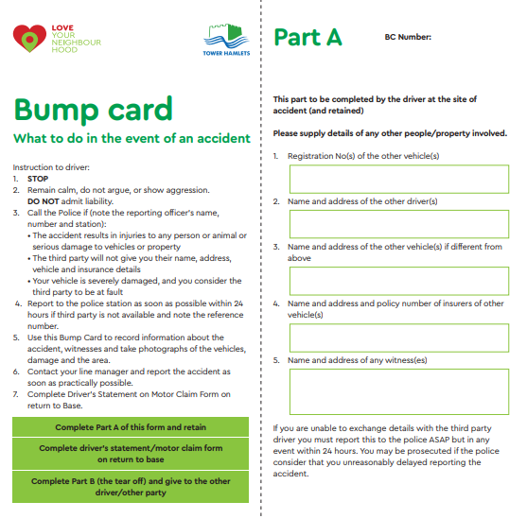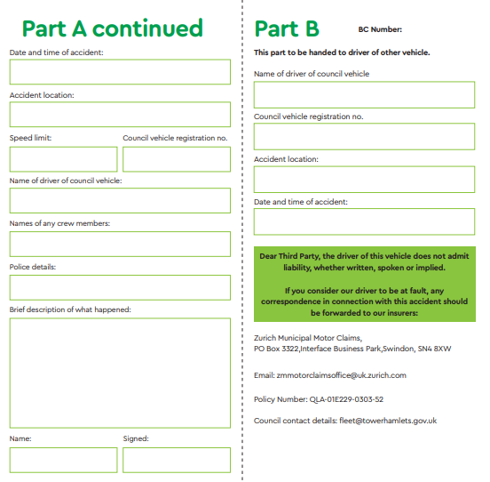

London Borough of Tower Hamlets
Motor Claim Form
Insured

QLA-01E229-0303-52

Zurich Municipal Policy Number TSU Claim No
London Borough of Tower Hamlets
Name Address
2 Silvocea Way
Blackwall
London
E14 0JJ

Contact details
Telephone: 0207 364 1518
Email: fleet@towerhamlets.gov.uk

Vehicle

Registration Number Make and Model
Driver details

Name Address

Telephone Number

Date of Birth

Occupation Department
Provisional / Full HGV / Motorcycle / Automatic only / International
How many years held ________________________
Driving Licence

Convictions
Yes / No

Conviction details
Please state year,
offence code, points,
notified insurers,
time served

Yes / No

Pending charges Pending charge details
Glasses / Contacts / None
Eyesight
If worn, were you
Wearing them at the
time of the accident?

Disabilities that affect driving:

Diabetes, Heart Conditions, DVLA noted,
Insurers note, medication
Date Time
_______ AM / PM

Accident details

Accident Location Lights
Yes / No
Street name, Were lights
Postcode showing

Speed limit
of road
Rain / Snow / Wind / Frost / Fog / Sunshine
Weather conditions

Speed
Dry / Wet/ Slippery/ Mud on road / Icy
Road conditions Speed of your vehicle
at the moment of
impact
Poor / Good / Excellent
Visibility

State fully what happened
Please describe the circumstances of the accident in full and draw a sketch, indicate vehicles, direction of travel and road markings

Description of own

Own damage
damage

Please indicate on diagram position of damage on own vehicle

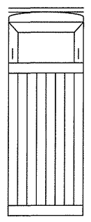

Third party vehicle / Property damage details

Name

Address Registration Number

Including Make/Model

Apparent damage to
TP vehicle / property
damage

Please indicate on diagram position of damage on third party vehicle

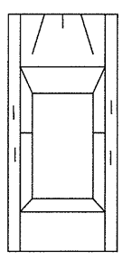
Injured person details

State the name and address (whether driver, passenger, pedestrian’s etc); full details of injury, medical attention if required; name of hospital

Please state whether independent or passengers in your vehicle
Witness
Please provide name and contact number

Police

Yes / No
Yes / No
Were police informed Did they attend

Police office details

Name of officer, reporting
station, police reference
number

Declaration

I believe the facts in this statement, signed by me, are true. I have no objections to a copy of the statement being passed to anyone who would have reasonable grounds to require a copy

Signature Date

Counter Date

signed
Line manager/Transport
manager

This form should be completed by the driver as soon as the details of an incident / accident are known.

Any associated photos or documents relating to the incident should be emailed to the Fleet Team

Fleet@towerhamlets.gov.uk

