Wapping Bus Gateway
Signage Review

14/04/2020

Introduction

1.1 Client Brief
Project Centre Limited (PCL) was commissioned by the London Borough of Tower Hamlets (LBTH) to undertake a review of the Wapping Bus Gateway signage to ensure it has been provided consistent with the Department of Transport’s Traffic Sign Manual Chapter 3 and appropriate to ensure residents and visitors know the times and the location of the bus gateway.
Additional consideration for the access of vehicles being used for police, fire brigade or ambulance purposes or anything done with the permission of or at the direction of a police constable in uniform or a person authorised by Transport for London (TfL) through the bus gateway was taken into account.
1.2 Background
The Wapping Bus Gateway is located on Wapping High Street and came into force on 13 November 2019 as part of an Experimental Traffic Order which is due to expire on 31 May 2021.
An interim review of the bus gateway is currently being undertaken to determine how the bus gateway has altered traffic volumes and traffic operations in the area. Part of this includes reviewing the existing bus gateway signage.
The bus gateway is located east of the junction of Wapping High Street and Sampson Street as shown in Figure 1. The bus gateway operates between 5.30am to 10.30am and 4pm to 7pm Monday to Friday.
Figure 1: Bus Gateway location (indicated by red box on Wapping High Street)
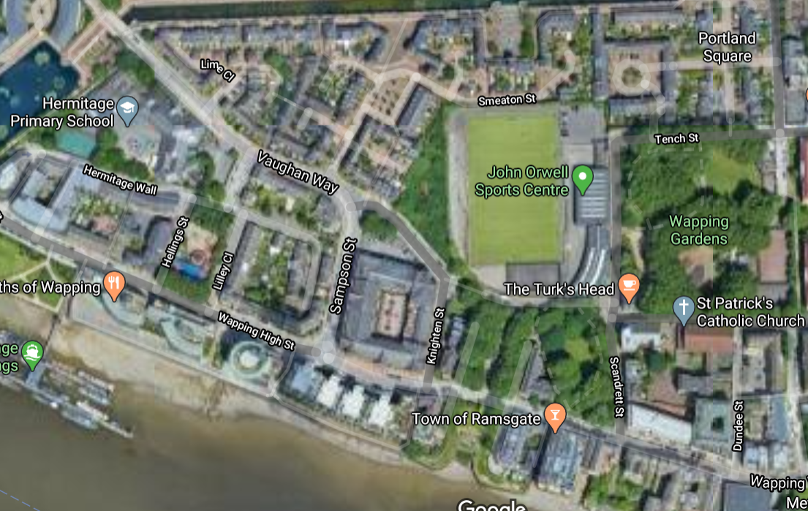

2. Restriction signage review
2.1 Experimental Traffic Order
The Order cited as the Tower Hamlets (Prescribed Routes) (Wapping High Street Bus Gateway) Experimental Traffic Order 2019, provides, by way of an experiment, a ‘bus gateway’ – being a point ‘no motor vehicles except local buses’ restriction in Wapping High Street, located at a point approximately 5 metres south-east of the south-eastern kerb-line build-out of Sampson Street. The restriction will apply to both north-westbound and south-eastbound vehicles in Wapping High Street and to vehicles approaching Wapping High Street from Sampson Street, and will operate between the hours of 5.30am and 10.30am and between the hours of 4pm and 7pm on Mondays to Fridays inclusive.
It is important to note that the order is for a prescribed route restricting no person to cause any motor vehicle other than a local bus to proceed during the prescribed hours to enter the identified part of carriageway. This is outlined in the order.
2.2 Signing options
A desktop review was conducted to determine if the bus gateway signage is consistent with the Department of Transport’s Traffic Sign Manual (TSM) and appropriate to ensure residents and visitors know the times and the location of the bus gateway. There are two ways of signing the restriction as part of bus only section of road (bus lane) or as a restriction to motor vehicle.
2.3 Bus only
In accordance to the Chapters 3 and 5 of TSM, the signage for use at a bus gate or for a section of carriageway for bus only would be Schedule 3 Part 2 Diagram 34 (S3-2-34, Diagram 953) in combination with the bus gate line marking Schedule 9 Part 6 Diagram 15 (S9-6-15, Diagram 1048.5).
Figure 2: TSM example of a two way bus gate
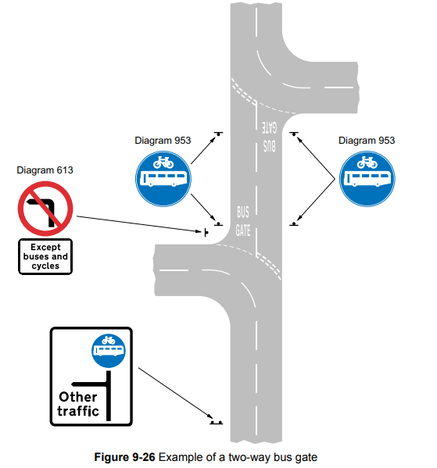

It should be noted that by providing a design in this way, the bus gate road marking is part of the required signage and would need to be installed.
Enforcement of this design and usage of S3-2-34 would require PCN 33 (using route restricted to certain vehicles).
2.4 Motor Vehicle restriction
In accordance to the Chapters 3 of TSM the signage for prohibition of Motor Vehicles for a section of carriageway is Schedule 3 Part 2 Diagram 12 (S3-2-12) in combination with a plate legend specifying the operation times with no line marking.
The existing signage at the bus gate can be seen in Figure 3: Existing Wapping Bus Gateway Signage and Line marking which is a combination of S3-2-12 motor vehicles prohibited, a plate legend and variant S11-2-63 enforcement camera sign. No line marking pertaining to the bus gate is required to be installed at the bus gate.
Figure 3: Existing Wapping Bus Gateway Signage and Line marking
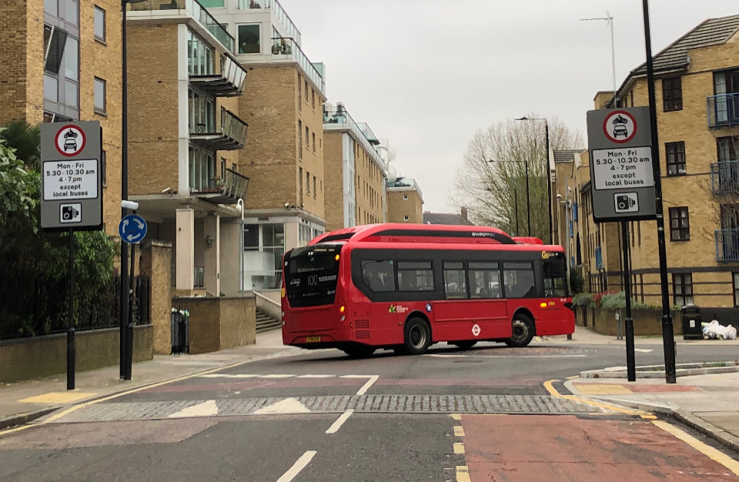
Enforcement of this design and usage of S3-2-12 would require PCN 52 (failing to comply with prohibition on certain types of vehicle).
2.5 Recommendation on signage design
The use of both these designs and signage are legally compliant and therefore can be used on Wapping High Street. It should be noted that due to there being a time restriction it is recommend that the motor vehicle prohibition order is used. This is because there is no requirement to place line marking on the carriageway. It would be deemed confusing to drivers if “Bus Gate” line markings were put on the carriageway when there are periods that it is not a bus gate and vehicles are allowed through.

Furthermore, the prohibition of motor vehicle signage and traffic order can be altered, if required, to allow for authorised vehicles (i.e. exemptions) to be added in the future.
2.6 Existing signage compliance
Following the site visit the signage at the bus gateway is in in accordance to Chapter 3 of TSM. Signs were observed from the appropriate distance for the speed of the road. No obstructions to the signs were observed on site when inspected from the carriageway and all signs were mounted above the 2100mm mounting height.
2.7 Recommendation on physical design
We are aware that this has been implemented as part of an experimental order however should this continue to a permanent feature; more physical works could take place to make it more visible to drivers. This could include but not limited to narrowing of the carriageway, carriageway colour, or street lighting features. It should be noted that any new implications should not lead to confusion for drivers during at which time the bus gateway is not in operation.

3. Advance warning signage

3.1 Background
In addition to the signage at the restriction, it is known that Wapping High Street is a rat-run for vehicles avoiding a queue on The Highway. Therefore, it is understood that providing signage in advance of the restriction would be both informative to drivers and reduce the number of vehicles entering Wapping before having to turn around due to the restriction.
This information signage has been in three forms:
- Information signage at the entry points to Wapping that will remain in place while the restriction is in place.
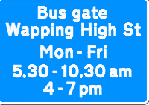
- Temporary signage along The Highway, to be in place for a short period.
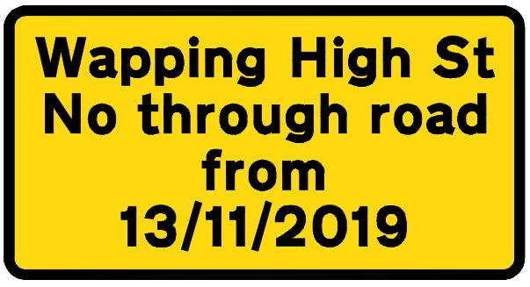
3) Advance warning signs on the approach to the restriction.
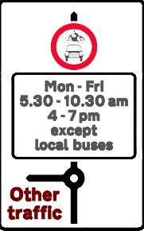
A signage plan has been provided as can be seen in Appendix A.
3.2 Site visit
A site visit was conducted on 19 March 2020 to review the signage in Appendix A and to ensure that all traffic entering Wapping is aware of the bus gateway location and times. Table 1 summarises the issues and recommended changes to the existing signage.
3.3 Existing signage compliance
Following the site visit the signage at the bus gateway is in in accordance to Chapter 3 of TSM all upright regulatory signs are required to be illuminated as per section 8.15. During the site visit it was found that all upright signs on junctions and all regulatory signs have been illuminated with a few exceptions due to either installation errors or vandalism. This has been outlined in detail in Table 1: Signage Review.
To ensure drivers can understand the signage information on approach to an intersection, speed limit signs should not be mounted with more than one other sign. The existing signage design and installation has complied with this instruction.
In the site audit of the signage installed, effort was made when possible to photograph the sign from the distance of 45m or 60m (as per Table 1-1, TSM Chapter 3) depending on approach speed of the area to determine visibility from the minimum clear visibility distance. All signs on site were determined to be visible.
No obstructions to the signs were observed on site when inspected from the carriageway (when safety permitted) and all signs were mounted above the 2100mm mounting height.
3.4 Observations
Following Chapter 2 of this report, the restriction in place and recommended is the prohibition of motor vehicles rather than the use of a Bus Gate. It could be conceived to be misleading that the advance warning signs advise of a bus gate rather than motor vehicle restriction.
The signs have been put in place for information and ultimately there to help the driver. Most of these are also temporary in nature. Advance signage is not in view or close to the actual restriction and therefore drivers cannot see both at the same time.
In addition, on all main approaches prior to the restriction there is one advance warning sign of the prohibition of motor vehicles. Therefore, not only is there compliant signage at the restriction but in advance there is also a compliant advance warning. This suggest that drivers cannot be confused by the presence of information signage and then the restriction that is on the carriageway.
3.5 Recommendation
The advanced warning signs of the bus gateway implemented on all approaches have been found to be very comprehensive with the exception of Pennington Street.
We have recommended implementing a sign at the intersection of Pennington Street and Wapping Lane in Table 1: Signage Review so all users will be aware of the bus gate.
Being that this is a conservation area the introduction of additional signage above and beyond what is sensibly required would be detrimental to the area.
In the on-site review, no barriers were found throughout the route which may impede access to vehicles being used for police, fire brigade or ambulance purposes or anything done with the permission of or at the direction of a police constable in uniform or a person authorised by TfL.

Table 1: Signage Review
Site Location | Photo | Issue | Recommendation
The Highway east of Glamis Road junction on southern footpath | 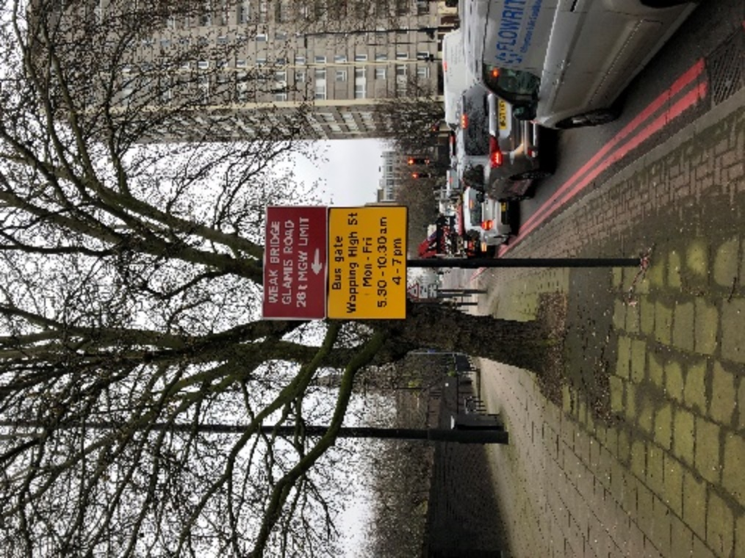 | A S13 sign is provided but not shown on the signage plan. It has yellow backing as per other S13 signs installed on The Highway. | The signage plan should be updated to include this sign.
Glamis Road south of The Highway  (Location N) | 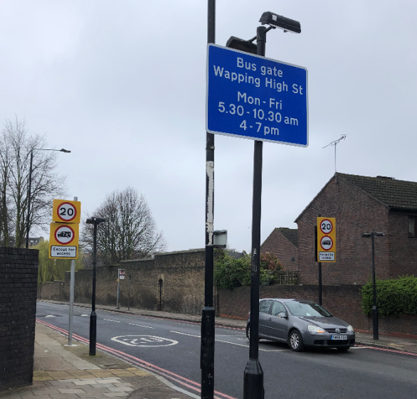 | The S06 sign on the eastern footpath is not mounted on the wide based post with illumination. | The existing wide based posts should be extended so the S06 signs are mounted and illuminated at the height specified in Chapter 3 section 8.17 of the Traffic Signs Manual.
The Highway east of the pedestrian crossing at Dellow Street on the southern footpath | 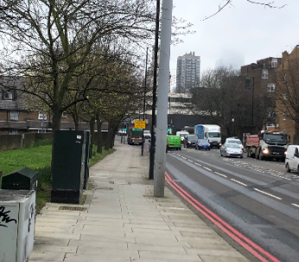 | A S13 sign is provided but not shown on the signage plan. It has yellow backing as per other S13 signs installed on The Highway. | The signage plan should be updated to include this sign.
Wapping Lane south of The Highway  (Location K) | 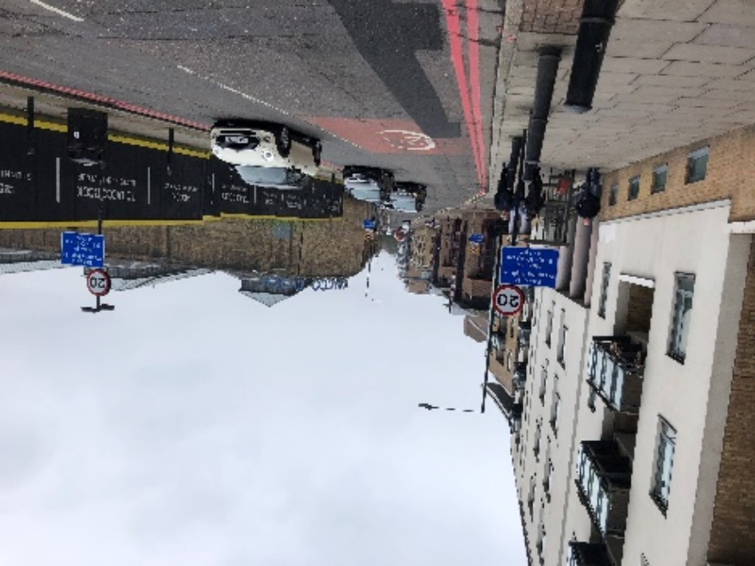 | The S09 sign on the eastern footpath is not illuminated. | The S09 sign should be illuminated as per Chapter 3 of Traffic Sign Manual section 8.15.
Pennington Street between Artichoke Hill and Chigwell Hill on the northern footpath | .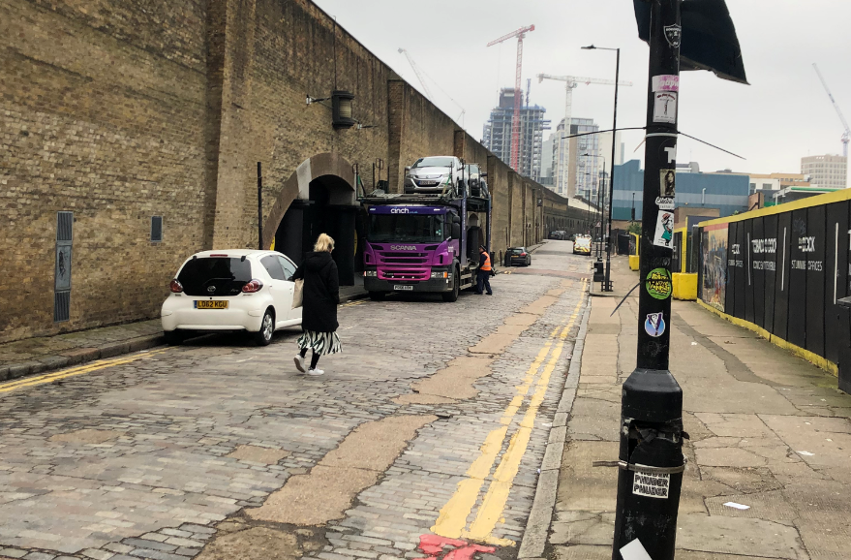 | It is possible to enter onto Wapping Lane from Pennington Street with no advance warning of the bus gateway | Supply and install S13 sign on Pennington Street
Wapping Lane south of Raine Street on the eastern footpath (Location Q) | 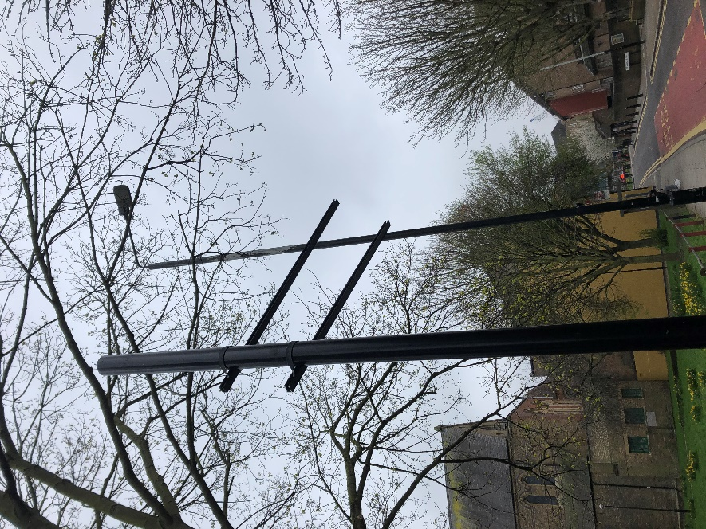 | The S13 sign is missing. Only the signpost and bracket remain. | Reinstall S13 sign
Wapping High Street between Lilley Close and Sampson Street  (Location B) | 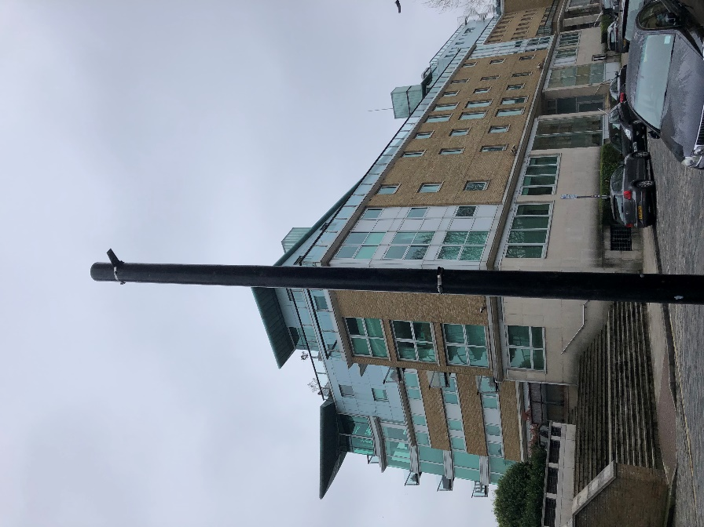 | The S03 sign is missing. Only the signpost and bracket remain. | Reinstall sign 03
East Smithfield west of opposite St Katharine Dock entrance on the northern footpath  (Location T1) | 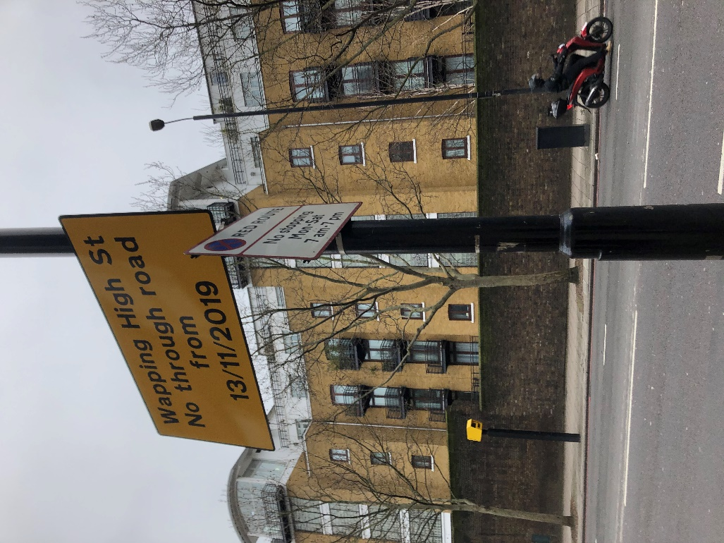 | The S15 sign has been rotated so it faces the wall and not eastbound traffic. | Rotate the S15 sign so it faces eastbound traffic.

