Dear Resident(s),

Important Information: Purple Recycling Bin – Misuse

Many residents recycle correctly but, unfortunately, some residents are placing general rubbish, black sacks and non-recyclable items in the purple recycling bins. Once this mixes in with the recycling, our collection crews cannot collect it for recycling as it has become contaminated. Contaminated recycling cannot be collected by the recycling collection team and causes a delay in emptying the bins, an added cost for the council and a reduction in the amount that can be recycled.

It is not possible to know who placed non-recyclable items in the bins, which is why this letter is being sent to all residents in the block as a reminder of what items should go into the purple bins:

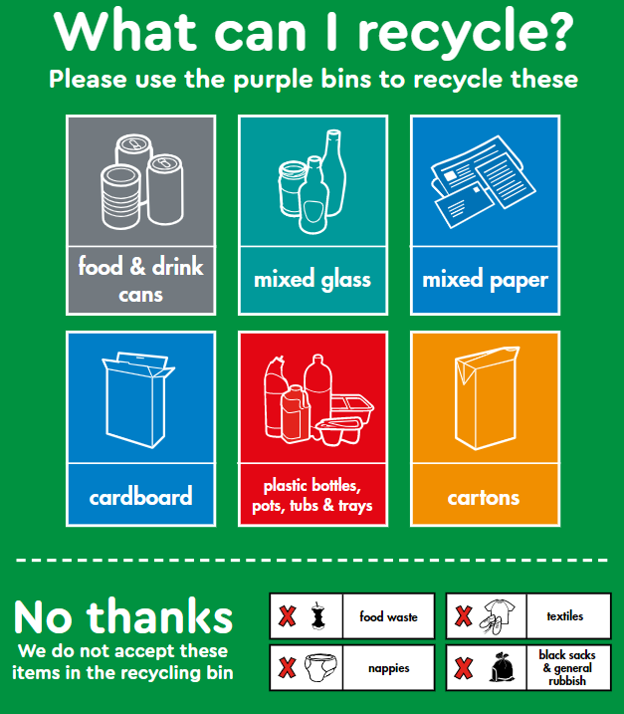
Empty your recycling into the bin. You can use a reusable bag (which the council can supply free of charge) to store and transport your loose recycling from your flat to the bins or you can use any clear sack. Please do not use black sacks for recycling.

Please flatten, fold or breakdown any carboard boxes before placing in the recycling bin.
You can order a reusable bag and find out more about recycling online at
www.towerhamlets.gov.uk/recycling

Thank you for your co-operation in recycling and maintaining a clean, safe, environment. If you have any queries, please contact [insert organisation name and contact details]
Yours faithfully

