Dear Resident,

Important Information: Recycling and Rubbish

Welcome your new home. As a resident, you have a responsibility to ensure that your recycling and rubbish is disposed of correctly, and without causing damage, nuisance, or health and safety issues to other residents or the local environment. Please make sure all members of your household understand this letter.

Recycling and Rubbish

- Recycling (purple bins) is collected weekly. Recycling bins are located at [insert]
- Rubbish is collected weekly. Rubbish bins are located at [insert]

Check your collection day at: www.towerhamlets.gov.uk/wastecollections
Missed collections should be reported after 3pm on the day to Tower Hamlets Council 020 7364 5000 or online at www.towerhamlets.gov.uk/wastcollections

For any other issue concerning recycling and rubbish at your block please contact [insert organisation name and contact details].

How to recycle

Recycling in Tower Hamlets is easy. Recycling can be placed in the purple bins loose or contained in any clear sack. You could use a reusable bag, ‘bag for life’, or cardboard box to store and transport your recycling from your flat to the bins. Black sacks should never be used for recycling. The council can supply a reusable bag and you can order one by contacting: recycle@towerhamlets.gov.uk. To find out more about recycling visit www.towerhamlets.gov.uk/recycling

Please flatten, fold or breakdown any carboard boxes before placing in the recycling bin.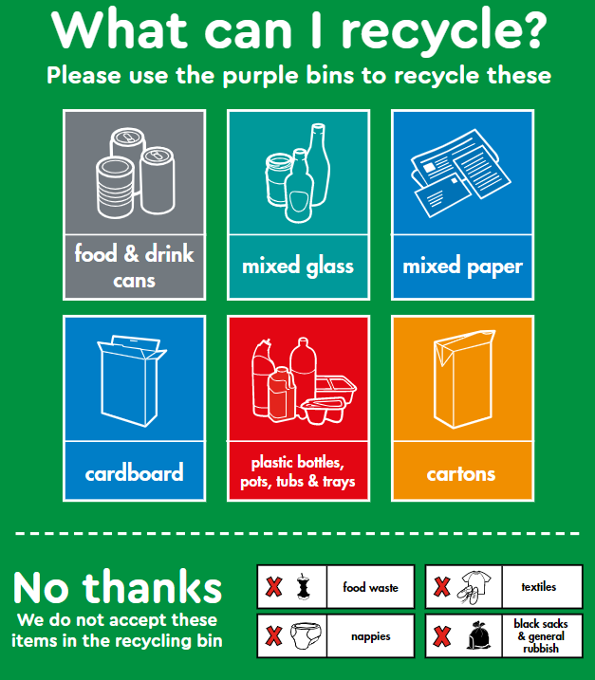

Bulk Rubbish

Please do not dump rubbish or any other items such as furniture, white goods, etc, at the bins. This is deemed as fly-tipping and you could receive a fine, as well as be liable for clear up costs. It also blocks access to the bins for other residents and collection crews.

Tower Hamlets Council offer a free collection service for residents where you can arrange for up to five items to be taken away. Terms and conditions apply, and you can book a collection via www.towerhamlets.gov.uk/bulkywaste.

Reuse and Recycling Centre

The Reuse and Recycling Centre is located at Yabsley Street, E14. You can recycle garden waste, and a whole range of household items. For further information, including what to bring, restrictions, and opening hours, please visit www.towerhamlets.gov.uk/recycling.

Thank you for your co-operation in maintaining a clean, safe environment. If you have any queries, please contact [insert organisation name and contact details].

Yours faithfully

