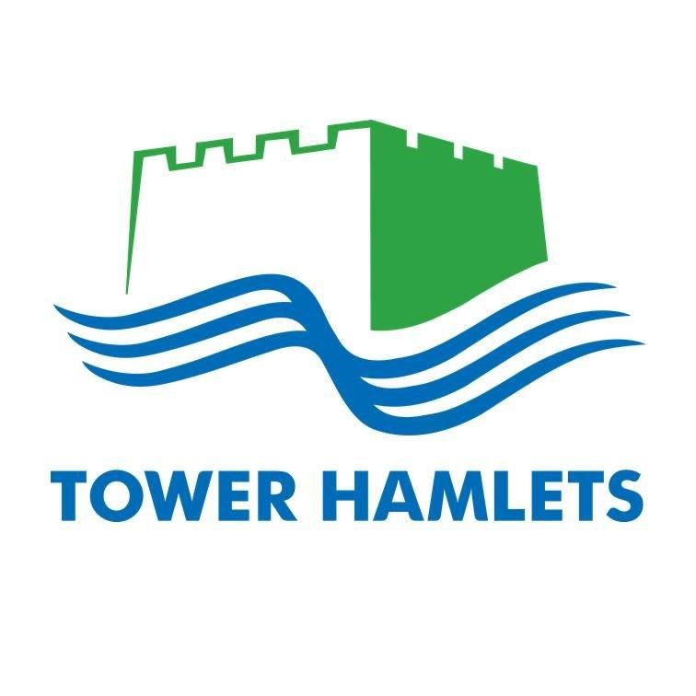
TOWER HAMLETS CAREERS SERVICE

Colleges/Schools offering Further Education Courses (Updated December 2018)

NB: We have listed one address for each, but many colleges have more than one campus.

Attlee A-level Academy  (part of New City College)  Arbour Square  London, E1 0PT  Tel:020 7510 7510  www.ncclondon.ac.uk/a-level-academy | Barking & Dagenham College  Dagenham Road,  Rush Green  Romford RM7 0XU  Tel: 020 3667 0294  www.barkingdagenhamcollege.ac.uk | Bishop Challoner 6th Form  352 Commercial Rd,  London E1 0LB  Tel: 020 7791 9500  www.bishopchallonerfederation.towerhamlets.sch.uk
Bow School  44 Twelvetrees Crescent,  London E3 3QW  Tel: 0207 536 5525  www.bow-school.org.uk | BSix  Brooke House Sixth Form College  Kenninghall Road  London E5 8BP  Tel: 020 8525 7150  www.bsix.ac.uk | Central Foundation Girls School  Aspire Building  41-47 Bow Road  London E3 2BS  Tel: 0208 981 1131  www.central.towerhamlets.sch.uk
Christ The King 6thFormCollege  Belmont Grove  Lewisham  London SE13 5GE  Tel: 020 8297 9433  www.ctksfc.ac.uk | Chobham Academy  40 Cheering Lane,  London E20 1BD  Tel: 0203 747 6060  www.chobhamacademy.org.uk | City & Islington College  (part of WKCIC)  283-309 Goswell Road  London EC1V 7LA  Tel: 020 7700 9200  www.candi.ac.uk
City of Westminster College  Paddington Green campus  25 Paddington Green  London W2 1NB  Tel: 020 7723 8826  www.cwc.ac.uk | College of Haringey, Enfield & North East London  High Road  London N15 4RU  Tel: 020 8442 3055  www.conel.ac.uk | George Green’s School  100 Manchester Road  London E14 3DW  Tel: 020 7987 6032  www.georgegreens.com
Harris Westminster Sixth Form  Steel House,  11 Tothill Street,  London, SW1H 9LH  Tel: 020 3772 4555  www.harriswestminstersixthform.org.uk | Havering College  Ardleigh Green Road  Hornchurch RM11 2LL  Tel: 01708 455 011  www.havering-college.ac.uk | Havering 6thForm College  Wingletye Lane  Hornchurch RM11 3TB  Tel: 01708 514 400  www.havering-sfc.ac.uk
Langdon Park School  Bright Street  London, E14 0RZ  Tel: 020 7987 4811  www.langdonparkschool.co.uk | Lewisham Southwark College  Lewisham Way  London SE4 1UT  Tel: 0800 834 545  www.lesoco.ac.uk | Leyton 6thFormCollege  Essex Road  London E10 6EQ  Tel: 020 8928 9000  www.leyton.ac.uk
London Academy of Excellence  Broadway House  322 High Street  London E15 1AJ  Tel: 020 3301 1480  www.lae.ac.uk | London South East Colleges  Greenwich Campus  95 Plumstead Road,  London SE18 7DQ  Tel: 0300 303 2554  www.lsec.ac.uk | Morpeth School  Portman Place  London E2 0PX  Tel: 020 8981 0921  www.morpethschool.org.uk
Mulberry Academy Shoreditch  (was Bethnal Green Academy)  Gosset Street  London E2 6NW  Tel: 0207 920 7900  www.mulberryacademyshoreditch.org | Mulberry School for Girls  Richard Street  Commercial Road  London E1 2JP  Tel: 020 7790 6327  www.mulberry.towerhamlets.sch.uk | New City College Epping Forest  (was Epping Forest College)  Borders Lane  Loughton IG10 3SA  Tel: 020 8508 8311  www.ncclondon.ac.uk/epping-forest
New City College Hackney  (was Hackney Community College)  Shoreditch Campus, Falkirk St  London N1 6HQ  Tel: 020 7613 9123  www.ncclondon.ac.uk/hackney | New City College Redbridge  (was Redbridge College)  Chadwell Heath Lane  Romford RM6 4XT  Tel: 020 8548 7402  www.ncclondon.ac.uk/redbridge | New City College Tower Hamlets  (was Tower Hamlets College)  Poplar High Street  London E14 0AF  Tel: 020 7510 7510  www.ncclondon.ac.uk/tower-hamlets
Newham College  Welfare Road  London E15 4HT  Tel: 020 8257 4000  www.newham.ac.uk | Newham Collegiate Sixth Form Centre  326 Barking Rd  London E6 2BB  Tel: 020 3373 5000  www.thencs.co.uk | NewVIc (Newham 6thFormCollege)  Prince Regent Lane  Plaistow, E13 8SG  Tel: 020 7473 4110  www.newvic.ac.uk
Oaklands School  Old Bethnal Green Road  London E2 6PR  Tel: 020 7613 1014  www.oaklandsschool.com | Raines Foundation School  Approach Road  London E2 9LY  Tel: 020 8981 1231  www.rainesfoundation.org.uk | St Charles Catholic 6thForm College  St Charles Square  London W10 6EY  Tel: 020 8968 7755  www.stcharles.ac.uk
St Paul's Way Trust School  125, St Paul's Way  London  E3 4FT  Tel: 020 7987 1883  www.spwt.net | Sir George Monoux 6th Form  190 Chingford Road  Walthamstow E17 5AA  Tel: 020 8523 3544  http://www.sgmc.ac.uk | Sir John Cass 6th Form College  Stepney Way  London E1 0RH  Tel: 020 7790 6712  www.sjcr.net
Six 21  Pitchford Street  London E15 4RZ  Tel: 020 8262 2121  www.six21.org.uk | South Quay College  (was City Gateway College)  32 Mastmaker Court  Mastmaker Road  London E14 9UB  Tel: 020 3727 6300  www.southquaycollege.org.uk | Stepney Green Maths, Computing & Science College  Ben Jonson Road,  London, E1 4SD  Tel: 020 7790 6361  www.stepneygreen.towerhamlets.sch.uk
Swanlea School  31 Brady Street  Whitechapel  London E1 5DJ  Tel: 020 7375 3267  http://swanlea.co.uk | Waltham Forest College  707 Forest Road  Walthamstow E17 4JB  Tel: 020 8501 8000  www.waltham.ac.uk | Westminster Kingsway College  (part of WKCIC)  Kings Cross Centre  211 Grays Inn Road  London WC1X 8RA  Tel: 020 7963 4181  www.westking.ac.uk

Specialist Colleges/Schools offering Further Education Courses

Access Creative College  (was Access to Music)  50 Hoxton Street  Shoreditch  London N1 6LP  0207 613 8380  www.accesscreative.ac.uk | Big Creative Education (was DV8)  BCE Academy Campus  Clifton Avenue  London E17 6HL  Tel: 020 8498 3300  www.bigcreative.education | The BRIT School for Performing Arts & Technology  60 The Crescent  Croydon CR0 2HN  Tel: 0208 665 5242  www.brit.croydon.sch.uk
Capel Manor College  Bullsmoor Lane  Enfield EN1 4RQ  Tel: 0303 003 1234  www.capel.ac.uk  (Animal Care, horticulture, floristry) | East London Arts & Music (ELAM)  Maltings Close,  London E3 3TA  Tel: 020 7515 2159  www.elam.co.uk | Fashion Retail Academy  15 Gresse Street  London W1T 1QL  Tel: 0300 247 3000  www.fashionretailacademy.ac.uk  (Fashion retail and design)
Hadlow College  Mottingham Lane  London SE12 9AW  Tel: 0808 555 1434  www.hadlow.ac.uk  (Animal Care, horticulture, floristry) | LCBT  Ramillies House  1-2 Ramillies St  London W1F 7LN  Tel: 020 7208 1300  www.lcbt.co.uk  (Hair, beauty and fitness) | London Design & Engineering UTC  Docklands Campus,  15 University Way,  London, E16 2RD  Tel: 0203 019 7333  www.ldeutc.co.uk  (design, engineering)
Mulberry UTC  64 Parnell Road  London E3 2RU  Tel: 020 3137 7024  www.mulberryutc.co.uk  (digital, creative, healthcare) | Sir Simon Milton Westminster UTC  1 Sutherland Street  London SW1V 4LD  020 2201 7660  www.westminsterutc.co.uk  (STEM) | Tech City College  263 – 269 City Road  London EC1V 1JX  Tel: 020 3301 3620  www.techcity-aspirations.org  (STEM)

