Year 11 Results Day Guide 2022.

This guide is to support those in year 11 who will be receiving their results on 25 August 2022. There is information about post-16 options including: A levels, BTEC, T levels, apprenticeships and more.

- The date to receive GCSE results is Thursday 25 August
- Other qualification results, such as a BTEC Level 3 will be available on or before Thursday 25 August and BTEC Level 2 will be on or before A level results day Thursday 18th August
- There is more information about this here or go to
www.gov.uk/government/organisations/ofqual

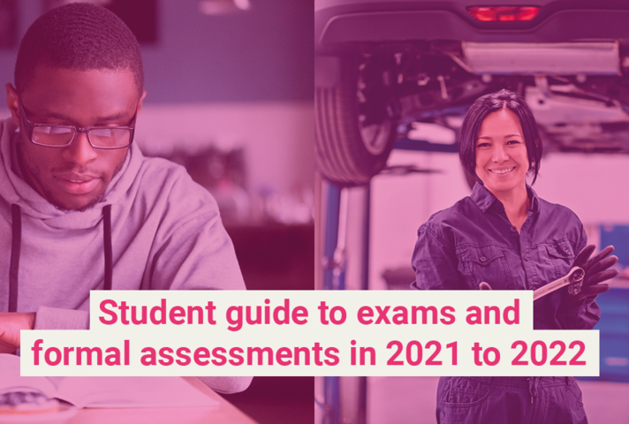

We will still be available to support you on results and other days. Careers Advisers will be available in your school on GCSE results day in the morning. You can also come in and see us on results days from 2pm – 4.30pm at WorkPath office, 55 Upper Bank Street, London, E14 5GR (near Poplar DLR and Canary Wharf DLR and tube stations).
Alternatively, contact us Monday – Friday 9am-12pm and 1pm-5pm as we will also offer careers interviews over the phone or via video.

Telephone: 020 7364 1401 or 0800 3581 2410 (free phone)

Email: youngworkpath@towerhamlets.gov.uk

We expect to be very busy, so please do be patient if contacting us. There is also information on our webpage www.towerhamlets.gov.uk/youngworkpath

What’s next?
The entry requirements can vary and often depend on the level.

A levels at college/sixth form

BTEC at college/sixth form

T levels at college/sixth form

Apprenticeship

Employment with training

NVQ at college/training provider and/or workplace

Traineeship

Foundation/entry at college or another provider

Volunteering with part-time education or training

Programme

Resit you might be able to do with an option above

Raising the participation age (RPA)

Raising the participation age means you must continue in education or training until you are 18, read more here or go to www.gov.uk/know-when-you-can-leave-school It does not mean you must stay in school; you can choose one of the following options:

- Full-time education, such as college or sixth form
- Work-based learning, such as an apprenticeship or traineeship
- Spend 20 hours or more a week working or volunteering, while in part-time education or training.

What are the different options?

More information here or go to www.towerhamlets.gov.uk/youngworkpath and at the bottom of the page select ‘I’m a young person’ and then ‘options after year 11’.

A level: Available in a range of subjects and you would usually pick 3/4 subjects, these might be new subjects that you haven’t studied before e.g., law. Usually require 5 GCSEs grades 4/5-9, including English Language and Maths and might require specific subject grades. You would study these for two years.

BTEC (levels from entry to level 3): a vocational qualification that involves a mixture of practical and academic learning and entry requirements will depend on what level. They are offered by school sixth forms and colleges.

The subjects available are related to broad job areas, e.g., business, performing arts, engineering, and health and social care. Usually, you study just one subject for one to two years. BTECs are the most common type of general vocational qualification, but you may come across others, such as CTECs (Cambridge Technicals).

T levels (16–19 year olds or up to the age of 25 who have an education, health, or care plan): started in 2020, these are two-year courses equivalent to three A levels and are available in selected schools and colleges in 10 career areas. Prepare students for work by combining 80 per cent of their time in the classroom and 20 per cent at an industry placement, that is for at least 45 days. For students who are not ready to progress onto a T level, from September 2022 there will be a one-year post-GCSE T level Transition Programme to prepare students for a T level.

Apprenticeships (levels from 2-7): a work, learn and earn option, where you are employed by a company to work 80% of the week (usually 4 days) and 20% studying (usually one day) for a qualification relevant to your job and is paid for by the company. Higher/degree levels you might need to be 18 and have level 3 qualifications. These are for a minimum of one year.

Employment (if with training sometimes called an ‘apprenticeship’ or ‘school leaver/training programme’): could be full or part time working for a company in a variety of sectors and entry requirements can vary. If an apprenticeship or school/college training programme, you would work for a company most of the week and get training/qualification for that job.

NVQ (levels 1-7): is another type of vocational qualification that involves training for a specific job, a work-based way of learning – which is carried out at a college, or workplace. Involves a range of on-the-job tasks and activities that are designed to test you on your ability to do a job effectively. They can also be studied as part of an apprenticeship.

Traineeships (sometimes called a ‘pre-apprenticeship’): are aimed at 16–24-year-olds, who are not quite ready for an apprenticeship and last up to six months. They offer the chance to do work experience, improve work skills and (if needed) gain English and Maths qualifications. Traineeships are not usually paid, but financial help may be available.

Foundation/entry level: This can be a course to prepare you to progress onto the next level and don’t usually require any qualifications, but if you did not pass English Language and Maths (grade 4 or higher) you will need to re-sit these until you at least pass them.

Volunteering: A great way to understand a business, explore career area/s, develop skills and meet new people. It can also look great on your CV.

Programme: there are various other programmes depending on circumstances and interests.

Resit: depending on your results you might be able to re-sit some subjects while working and/or studying. If you did not pass English Language and Maths (grade 4 or higher) you will need to re-sit until you at least pass both.

Results day

- I have applied and been offered a place:
If you have received enrolment/start date information, then follow the college/sixth form or company instructions. If not, then contact them directly.

- I have applied and not been offered a place:
Contact the sixth form/college directly to enquire further. If it’s a work-based option, like an apprenticeship you can ask the company for feedback but do keep applying to others. Get in contact with us if you would like us to support you with this.

- I did not get the grades I wanted:
Hopefully you can still progress onto your next step, contact them to find out. You should speak to school staff about your grades and appeals, as remarking ('reviews of results') any exams will be done through them (unless a private candidate/home schooled). However, there could be a fee and your grade/s could go up or even down. There is further information in the Ofqual guide here or go to https://www.gov.uk/government/publications/student-guide-to-exams-and-formal-assessments-in-2021-to-2022/student-guide-to-exams-and-formal-assessments-in-2021-to-2022#what-happens-after-you-have-taken-your-exam-or-formal-assessment

- Resits:
If you did not pass English Language and Maths (grade 4 or higher) you will need to re-sit these until you pass them and could be alongside another option. The resit will take place in the November exam series and retakes for other subjects take place the following summer. For resit/s some students may choose to study independently and enter exams as private candidates. Private candidates register to take exams in a school, college or other type of exam centre. Some exam centres only deliver assessments and exams, and do not teach students. There could be a charge.

- I have not made any applications:
There might be places available at college/sixth form but depends on where, what course/s you want to study and your results. Click here or go to www.towerhamlets.gov.uk/youngworkpath for a college/sixth form list and contact directly, contact us if need help with this. If you want to apply to a work-based option, one of our team can also help you and you can also use the resources below to search for vacancies.
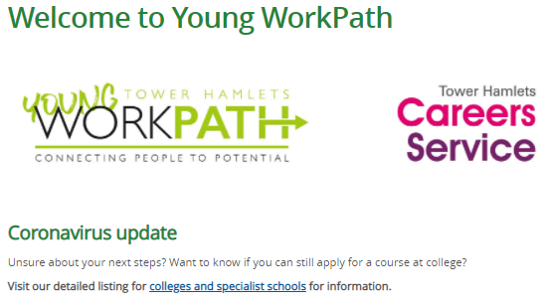

- Be prepared!
If you didn’t do as well as expected, it doesn’t mean that you cannot progress. Get support from those around you: at home, school staff, sixth form/college and at Careers Young WorkPath. Come in and see us on results days from 2pm – 4.30pm at WorkPath office, 55 Upper Bank Street, London, E14 5GR (near Poplar DLR and Canary Wharf DLR and tube stations). Alternatively, contact us Monday – Friday 9am-12pm and 1pm-5pm as we will also offer careers interviews over the phone or via video. Telephone: 0207 364 1401 or 0800 3581 2410 (free phone) or email: youngworkpath@towerhamlets.gov.uk

On the day, have your results, any acceptance letters/emails, a fully charged device with telephone and Internet access and notepad and pen. If you’re going into school to collect your results, also take these with you in case you need to make phone call/s and take notes.
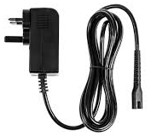
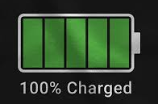

Resources

Various careers information and results day support:
- Young WorkPath www.towerhamlets.gov.uk/youngworkpath
- Ofqual www.gov.uk/government/organisations/ofqual
- UCAS www.ucas.com/
- National Careers Service (lines are open from 08:00 to 20:00 Monday to Friday and 10:00 to 17:00 on Saturdays) www.gov.uk/careers-helpline-for-teenagers
- National Careers Service course search https://nationalcareers.service.gov.uk/find-a-course/search (make sure you select the appropriate options)
- Careermap https://careermap.co.uk/gcse-results-day-guide-need-to-know/
- BBC Bitesize www.bbc.co.uk/bitesize/articles/z999r2p
- The UniGuide https://www.theuniguide.co.uk/advice/gcse-choices-university/gcse-results-day-2015-what-to-expect
- Start https://guest.startprofile.com/

A few for apprenticeships (also check company website/s directly):
- Apprenticeships www.apprenticeships.gov.uk
- Not Going to Uni www.notgoingtouni.co.uk/
- UCAS https://careerfinder.ucas.com/searchjobs/
- Indeed www.indeed.co.uk/
- All About School Leavers www.allaboutschoolleavers.co.uk/
- Get My First Job www.getmyfirstjob.co.uk/

