Year 13 Results Day Guide 2022

This guide to support those in year 13 who will be receiving their A level results on 18th August 2022. There is information about university options and other alternatives, including apprenticeships.

- The date to receive A level grades is Thursday 18 August (GCSE is Thursday 25 August)
- Other qualification results, such as a BTEC Level 3 will be available on or before Thursday 25 August and BTEC Level 2 will be on or before A level results day Thursday 18 August
- UCAS clearing will be open for students to apply at 3pm and close on 18 October. Contact UCAS for students 0371 468 0468.
- There is more information about examinations here or go to
www.gov.uk/government/organisations/ofqual

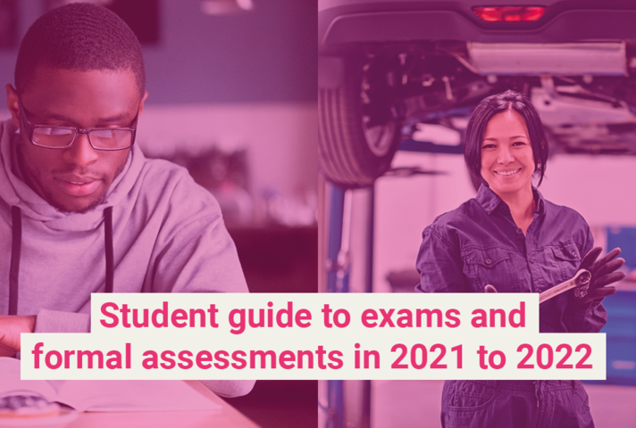

We will still be available to support you on results and other days. Come in and see us on results days from 2 – 4.30pm at WorkPath office, 55 Upper Bank Street, London, E14 5GR (near Poplar DLR and Canary Wharf DLR and tube stations).
Alternatively, contact us Monday – Friday 9am-12pm and 1-5pm as we will also offer careers interviews over the phone or via video.

Telephone: 020 7364 1401 or 0800 3581 2410 (freephone)

Email: youngworkpath@towerhamlets.gov.uk

We expect to be very busy, so please do be patient if contacting us. There is also information on our webpage www.towerhamlets.gov.uk/youngworkpath

What could you do after year 13?
The entry requirements can vary and often depend on the level.

What are the different options?

More information here or go to www.towerhamlets.gov.uk/youngworkpath and at the bottom of the page select ‘I’m a young person’ and then ‘options after sixth form or college’.

University: full or part time, which can be from 2-6 years (usually 3). Usually requires a level 3 qualification, such as A levels/BTEC/T level and often GCSEs, sometimes specific subject/s but depends on the course and the university.

Apprenticeships levels from 2-7: a work, learn and earn option, where you are employed by a company to work 80% of the week (usually 4 days) and 20% studying (usually one day) for a qualification relevant to your job and is paid for by the company. Higher/degree levels you might need to be 18 and have level 3 qualifications. These are for a minimum of one year.

Employment (if with training sometimes called an ‘apprenticeship or school leaver/training programme’): could be full or part- time working for a company in a variety of sectors and entry requirements can vary. If an apprenticeship or school/college training programme, you would work for a company most of the week and get training/qualification for that job.

Traineeships: (sometimes called a ‘pre-apprenticeship’): are aimed at 16–24-year-olds, who are not quite ready for an apprenticeship and last up to six months. They offer the chance to do work experience, improve work skills and (if needed) gain English and Maths qualifications. Traineeships are not usually paid, but financial help may be available.

Gap Year: There can be different reasons for wanting to take a year out, but most people do work and/or travel. Some companies have gap year schemes where you usually apply to before you finish year 13 and are only for that year but sometimes can be offered a permanent job or a job after university. Check for any travel restrictions.

T levels (16–19 year olds or up to the age of 25 who have an education, health, or care plan): started in 2020, these are two-year courses equivalent to three A levels and are available in selected schools and colleges in 10 career areas. Prepare students for work by combining 80 per cent of their time in the classroom and 20 per cent at an industry placement, that is for at least 45 days. For students who are not ready to progress onto a T level, from September 2022 there will be a one-year post-GCSE T level Transition Programme to prepare students for a T level.

BTEC (levels from entry to level 3): a vocational qualification that involves a mixture of practical and academic learning and entry requirements will depend on what level. They are offered by school sixth forms and colleges.

The subjects available are related to broad job areas, e.g., business, performing arts, engineering, and health and social care. Usually, you study just one subject for one to two years. BTECs are the most common type of general vocational qualification, but you may come across others, such as CTECs (Cambridge Technicals).

NVQ (levels 1-7): is another type of vocational qualification that involves training for a specific job, a work-based way of learning, which is carried out at a college, or workplace. Involves a range of on-the-job tasks and activities that are designed to test you on your ability to do a job effectively. They can also be studied as part of an apprenticeship.

Traineeships: (sometimes called a ‘pre-apprenticeship’): sometimes called by other names, such as ‘pre-apprenticeship’. Traineeships are aimed at 16–24-year-olds and last up to six months. They offer the chance to do work experience, improve work skills and (if needed) gain English and Maths qualifications. Traineeships are not usually paid, but financial help may be available.

Programme: there are various other programmes depending on circumstances and interests.

Volunteering: A great way to understand a business, explore career area/s, develop skills and meet new people. It can also look great on your CV.

Re-sits: depending on your results you might be able to re-sit some subjects while working and/or studying. If you did not pass English Language and Maths (grade 4 or higher) you will need to re-sit until you at least pass both.

- I have applied to university, have my offers, and not replied:
Your reply date is unique to you – log into Track or go to https://www.ucas.com/undergraduate/after-you-apply/access-your-application to see your deadline. Click here for a video or go to https://www.ucas.com/undergraduate/after-you-apply/tracking-your-ucas-application

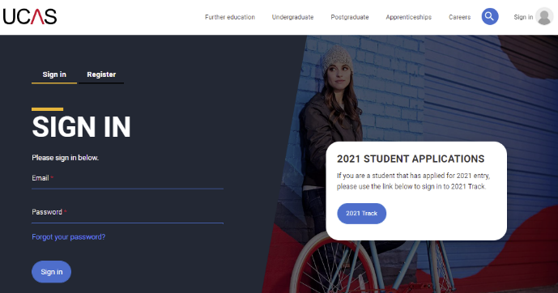

- I have applied to start university in 2022 and replied to my offers but I would like to defer to start 2023:
You’ll need to contact the university or college directly. Click here to read more information from UCAS or go to https://www.ucas.com/undergraduate/applying-university/when-apply/deferred-entry#:~:text=How%20to%20defer%20your%20application,choice%20on%20your%20UCAS%20application.

- I have applied to university but not been given any offers – Clearing:
Clearing is how universities and colleges fill places they still have on their courses and applicants without a place. From 5 July – 18 October, you can contact as many universities as you would like to check if the course still has places. Clearing Plus is where UCAS personally match you to courses you may be interested in, using what UCAS knows about you from your application, and what universities and colleges are looking for, but you can still search for something different. Click here for information or go to https://www.ucas.com/clearing-launch
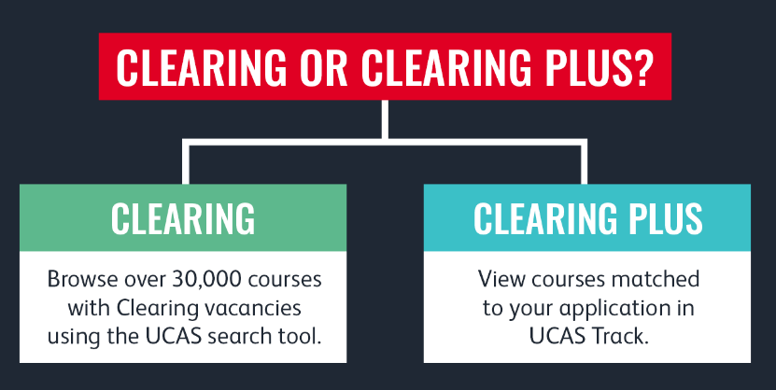

- I did not get the grades I wanted:
You should speak to school staff about your grades and appeals, as remarking ('reviews of results') will be done through them (unless a private candidate/home schooled). However, there could be a fee and your grade/s could go up or even down. There is further information in the Ofqual guide here or go to https://www.gov.uk/government/publications/student-guide-to-exams-and-formal-assessments-in-2021-to-2022/student-guide-to-exams-and-formal-assessments-in-2021-to-2022#what-happens-after-you-have-taken-your-exam-or-formal-assessment

- Resits:
If you did not pass English Language and Maths (grade 4 or higher) you will need to re-sit these until you pass them and could be alongside another option. The resit will take place in the November exam series and retakes for other subjects take place the following summer. For resit/s some students may choose to study independently and enter exams as private candidates. Private candidates register to take exams in a school, college or other type of exam centre. Some exam centres only deliver assessments and exams, and do not teach students. There could be a charge.

- I do not want an offer I've accepted:
If you are holding a university firm unconditional place you no longer wish to take, you can use the ‘Decline my place’ button in your application. If another option, such as an apprenticeship then contact directly.

- I have not made any applications:
If you want to go to university, use clearing with information above. If you want to apply to a work-based option, like an apprenticeship one of our team can help if you contact us and you can also use the resources below to search for vacancies.

Results day

Click here for information from UCAS or go to www.ucas.com/undergraduate/results-confirmation-and-clearing/results/what-your-application-status-means

Conditional place - if you have applied to university and your offer/s are conditional on your results have your Track login details ready to check the status. There are different possible options depending on your results.

Unconditional place - If you're taking exams but have been made an unconditional offer, your results won't affect whether you get accepted. But check the offer to see any changes and if there's anything else you need to do. If you are holding a university firm unconditional place you no longer wish to take, you can use the ‘Decline my place’ button in your application.

Adjustment - www.ucas.com/ucas-adjustment - is not available for the 2022 results period, therefore if you wish to secure a different place this year, you will need to decline the confirmed place and find a new place using Clearing. You can use Clearing Plus to find relevant universities with spaces whose entry requirements match your results.

Clearing - Many universities already have information on their website and UCAS has a list here.

Work based opportunity - if you have applied for an apprenticeship or employment and the offer was based on your grades, do contact the company directly for more information. If you have met the grades needed and the company has sent you induction/contract details, do follow up any instructions.

Be prepared!
If you didn’t do as well as expected, it doesn’t mean that you cannot progress. Get support from those around you: sixth form/college staff and from Careers Young WorkPath. Come in and see us on results days from 2pm – 4.30pm at WorkPath office, 55 Upper Bank Street, London, E14 5GR (near Poplar DLR and Canary Wharf DLR and tube stations). Alternatively, contact us Monday – Friday 9am-12pm and 1pm-5pm as we will also offer careers interviews over the phone or via video. Telephone: 0207 364 1401 or 0800 3581 2410 (free phone) or email: youngworkpath@towerhamlets.gov.uk

On the day, have your results, any acceptance letters/emails, your UCAS login details (if you’ve applied to university). If you’re going into college/sixth form to collect your results also take these with you in case you need to make phone call/s and take notes.

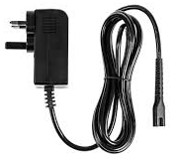
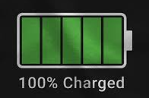

Resources

Various careers/results day information:
- Young WorkPath www.towerhamlets.gov.uk/youngworkpath
- Ofqual www.gov.uk/government/organisations/ofqual
- UCAS www.ucas.com/
- National Careers Service (lines are open from 08:00 to 20:00 Monday to Friday and 10:00 to 17:00 on Saturdays) www.gov.uk/careers-helpline-for-teenagers
- National Careers Service course search https://nationalcareers.service.gov.uk/find-a-course/search (make sure you select the appropriate options)
- Careermap https://careermap.co.uk/gcse-results-day-guide-need-to-know/
- BBC Bitesize www.bbc.co.uk/bitesize/articles/z999r2p
- Start https://guest.startprofile.com/
- Prospects – results day https://www.prospects.ac.uk/applying-for-university/getting-into-university/what-to-do-on-a-level-results-day
- The Uni Guide https://www.theuniguide.co.uk/advice/clearing-results-day/a-level-results-day-grades-what-to-expect
- Career map https://careermap.co.uk/a-level-results-day-what-you-need-to-know/#:~:text=A%20Level%20Results%20Day%20is%20Tuesday%20the,2021%20in%20England%20and%20Wales.

A few links for apprenticeships and jobs (check company website/s directly):
- Apprenticeships www.apprenticeships.gov.uk
- Not Going to Uni www.notgoingtouni.co.uk/
- UCAS https://careerfinder.ucas.com/searchjobs/
- Indeed www.indeed.co.uk/
- All About School Leavers www.allaboutschoolleavers.co.uk/
- Get My First Job www.getmyfirstjob.co.uk/
- Student job www.studentjob.co.uk/part-time-job/london
- Jobs Retail www.jobsretail.co.uk
- Life Skills www.barclayslifeskills.com

Taking a gap year
- UCAS https://www.ucas.com/undergraduate/student-life/gap-year/gap-years-ideas-and-things-think-about
- National Careers Service https://nationalcareers.service.gov.uk/careers-advice/advice-on-a-gap-year
- Year Out Group www.yearoutgroup.org - association for over 30 gap year organisations
- Year in industry STEM placements http://www.etrust.org.uk/the-year-in-industry

Studying abroad
- Top Universities www.topuniversities.com
- Advice on studying in the USA www.fulbright.org.uk
- Opportunities to study in Europe www.britishcouncil.org/erasmus

