Year 11 Results Day Guide 2021

This guide to support those in year 11 who will be receiving their results in August 2021. There is information about post-16 options including: A levels, BTEC, apprenticeships and more.

- Students have been affected by the pandemic and many exams and assessments have been cancelled this year. Your teachers will give you a grade based on your work.
- The date to receive GCSE grades is Thursday 12 August
- Other qualification results, such as a BTEC will be no later than GCSEs and A levels (A levels is Tuesday 10th August)
- There is more information about this here

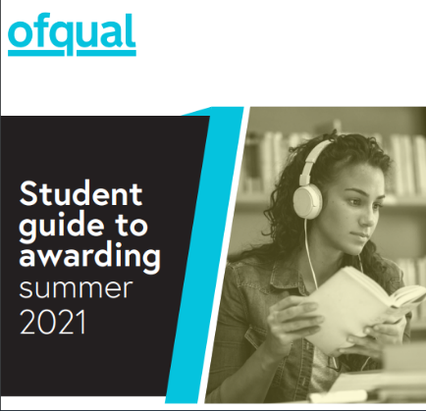

We will still be available to support you on results and other days, contact us Monday – Friday 9am-12pm and 1pm-5pm

Telephone: 0207 364 1401 or 0800 3581 2410 (free phone)

Email: youngworkpath@towerhamlets.gov.uk

We expect to be very busy, so please do be patient if contacting us.There is also information on our webpage www.towerhamlets.gov.uk/youngworkpath

What’s next?

The entry requirements can vary and often depend on the level.
18+ years old
16 and 18+ years old

University could be part or full time
A-levels at college/sixth form

Gap year
BTEC at college/sixth form

Apprenticeship at workplace and training provider

Employment with training at workplace and training provider

T Levels a mix of classroom learning and 'on-the-job' placement experience

NVQ at college and/or workplace

Traineeship

Kickstart

Foundation/entry at college or another provider

Resits you might be able to do with an option above

Raising the participation age (RPA)

Raising the participation age means you must continue in education or training until you are 18, read more here. It does not mean you must stay in school; you can choose one of the following options:

- Full-time education, such as college
- Work-based learning, such as an apprenticeship or traineeship
- Spend 20 hours or more a week working or volunteering, while in part-time education or training.

What are the different options? More information here.

A-level: Available in a range of subjects and you would usually pick 3/4 subjects, these might be new subjects that you haven’t studied before e.g., law. Usually require 5 GCSEs grades 4/5-9, including English and Maths and might require specific subject grades. You would study these for two years.

BTEC levels from entry to level 3: mixture of practical and academic learning and entry requirements will depend on what level. They are offered by school sixth forms and colleges.

The subjects available are related to broad job areas, e.g. business, performing arts, engineering, and health and social care. Usually, you study just one subject for one to two years.

Apprenticeships levels from 2-7: a work, learn and earn option, where you are employed by a company to work 80% of the week (usually 4 days) and 20% studying (usually one day) for a qualification relevant to your job and is paid for by the company. Higher/degree levels you might need to be 18 and have level 3 qualifications. These are for a minimum of one year.

Employment with training (sometimes called an ‘apprenticeship’): entry requirements will depend on what level. This could be a school leaver/training programme and are like apprenticeships where you would work for a company most of the week and get training for that job.

T Levels (16–19-year-olds): are new two-year courses equivalent to three levels, available to students in England from September 2020. Based on the same standards as apprenticeships, designed by employers, and offer around 1,800 hours of study and a 45-day work placement.

NVQ levels 1-8: is a work-based way of learning – which is carried out at a college, or workplace. Involves a range of on-the-job tasks and activities that are designed to test you on your ability to do a job effectively.

Traineeships: sometimes called by other names, such as ‘pre-apprenticeship’. Traineeships are aimed at 16–24-year-olds and last up to six months. They offer the chance to do work experience, improve work skills and (if needed) gain English and Maths qualifications. Traineeships are not usually paid, but financial help may be available.

Kickstart (only for 16–24-year-olds claiming Universal Credit): is a 6-month paid job with a local employer. Jobs are normally 25 hours per week and pay at least the National Minimum Wage or National Living Wage depending on how old you are.

Re-sits: depending on your results you might be able to re-sit some subjects while working and/or studying. If you did not pass English and Maths (grade 4 or higher) you will need to re-sit these until you pass them.

Foundation/entry level: This can be a course to prepare you to progress onto the next level and don’t usually require any qualifications, but if you did not pass English and Maths (grade 4 or higher) you will need to re-sit these until you pass them.

- I have applied and been offered a place:

If you have received enrolment/start date information, then follow the college/sixth form or company instructions. If you haven’t received this then contact them directly.

- I have applied and not been offered a place:

Contact the sixth form/college directly to enquire further. If it’s a work-based option, you can ask the company for feedback but do keep applying to others. Get in contact with us if you would like us to support you with this.

- I did not get the grades I wanted:

Hopefully you can still progress onto your next step, contact them to find out. You can speak to school staff about your grades and there is further information, including appeals in the Ofqual guide here.

- I have not made any applications:

There might be places available at college/sixth form but depends on where, what course/s you want to study and your results. Click here for a list and contact directly. If you want to apply to a work-based option, one of our team can help if you contact us and you can also use the resources below to search for vacancies.
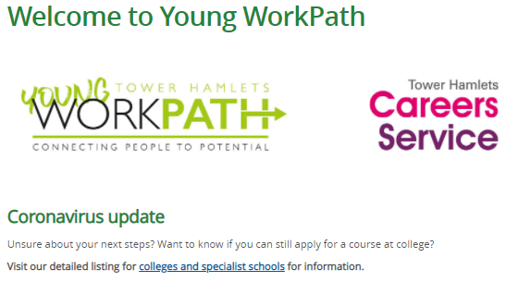

- Be prepared!

If you didn’t do as well as expected, it doesn’t mean that you cannot progress. Get support from those around you: at home, school staff, sixth form/college and us at Young WorkPath.

On the day, have a fully charged device with telephone and Internet access. If you’re going into school to collect your results, take your charger/s, notepad and pen in case you need to make phone call/s and take notes.

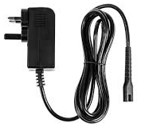
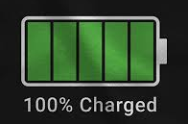

Resources

Various careers information and results day support:
Young WorkPath www.towerhamlets.gov.uk/youngworkpath
UCAS www.ucas.com/
National Careers Service www.gov.uk/careers-helpline-for-teenagers
Careermap https://careermap.co.uk/gcse-results-day-guide-need-to-know/
BBC Bitesize www.bbc.co.uk/bitesize/articles/z999r2p
Start https://guest.startprofile.com/

Apprenticeships (also check company website/s directly):
Apprenticeships www.apprenticeships.gov.uk
Not Going to Uni www.notgoingtouni.co.uk/
UCAS https://careerfinder.ucas.com/searchjobs/
Indeed www.indeed.co.uk/
All About School Leavers www.allaboutschoolleavers.co.uk/
Get My First Job www.getmyfirstjob.co.uk/

