Year 13 Results Day Guide 2021

This guide to support those in year 13 who will be receiving their results in August 2021. There is information about university options and other alternatives, including apprenticeships.

- Students have been affected by the pandemic and many exams and assessments have been cancelled this year. Your teachers will give you a grade based on your work.
- The date to receive A level grades is Tuesday 10th August (GCSE is Thursday 12th August)
- Other qualification results, such as a BTEC will be no later than GCSEs and A levels results day
- There is more information about this here
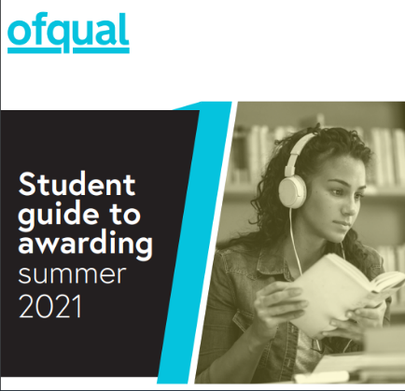

We will still be available to support you on results and other days, contact us
Monday – Friday 9am-12pm and 1pm-5pm

Telephone: 0207 364 1401 or 0800 3581 2410 (free phone)

Email: youngworkpath@towerhamlets.gov.uk

We expect to be very busy, so please do be patient if contacting us.
There is also information on our webpage www.towerhamlets.gov.uk/youngworkpath

What can you do after year 13?
University –
Full or part time
Employment with or without training

Apprenticeship
80% paid work
20% study

Gap year

NVQ/BTEC

Traineeship

Re-sits
Kickstart
T Levels

What are the different options? More information here

University: full or part time, which can be from 2-6 years (usually 3). Usually requires a level 3 qualification, such as A-levels/BTEC and often GCSEs, sometimes specific subject/s but depends on the course and the university.

Apprenticeships levels from 2-7: a work, learn and earn option, where you are employed by a company to work 80% of the week (usually 4 days) and 20% studying (usually one day) for a qualification relevant to your job and is paid for by the company. Higher/degree levels you might need to be 18 and have level 3 qualifications. These are for a minimum of one year.

Employment with training (sometimes called an ‘apprenticeship’): entry requirements will depend on what level. This could be a school leaver/training programme and are like apprenticeships where you would work for a company most of the week and get training for that job.

Employment without training: could be full or part time working for a company in a variety of sectors.

T Levels (16-19-year-olds): are new two-year courses equivalent to three levels, available to students in England from September 2020. Based on the same standards as apprenticeships, designed by employers, and offer around 1,800 hours of study and a 45-day work placement.

NVQ levels 1-8: is a work-based way of learning – which is carried out at a college or workplace. Involves a range of on-the-job tasks and activities that are designed to test you on your ability to do a job effectively.

Traineeships: sometimes called by other names, such as ‘pre-apprenticeship’. Traineeships are aimed at 16–24-year-olds and last up to six months. They offer the chance to do work experience, improve work skills and (if needed) gain English and Maths qualifications. Traineeships are not usually paid, but financial help may be available.

Kickstart (only for 16–24-year-olds claiming Universal Credit): is a 6-month paid job with a local employer. Jobs are normally 25 hours per week and pay at least the National Minimum Wage or National Living Wage depending on how old you are.

Re-sits: depending on your results you might be able to re-sit some subjects while working and/or studying. If you did not pass English and Maths (grade 4 or higher) you will need to re-sit these until you pass them.

Gap Year: There can be different reasons for wanting to take a year out, but most people do work and/or travel. Some companies have gap year schemes where you usually apply to before you finish year 13 and are only for that year but sometimes can be offered a permanent job or a job after university. Travel might be more difficult this year due to Covid-19 restrictions.

I have applied to university, have my offers and not replied:

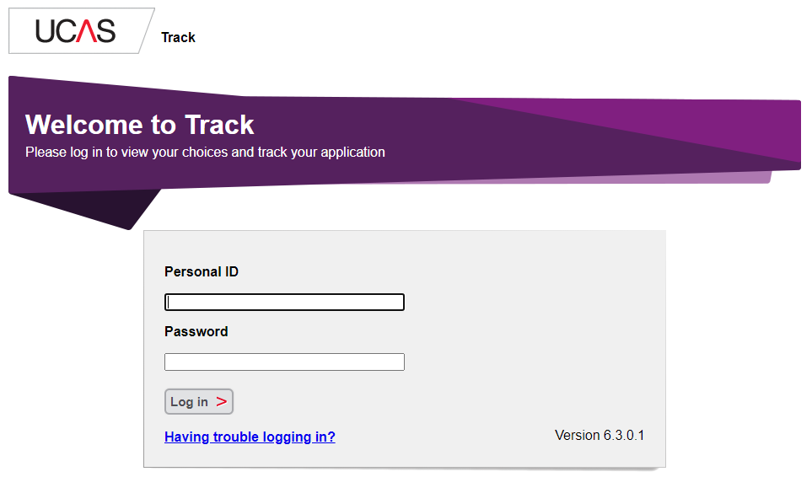
Your reply date is unique to you – log into Track to see your deadline. Click here for a video.

I have applied to start university in 2021 and replied to my offers but I would like to defer to start 2022:

You’ll need to contact the university directly. Click here to read more information from UCAS.

I have applied to university but not been given any offers – Clearing:

Clearing is how universities and colleges fill any places they still have on their courses. From 6 July – 19 October, you can contact as many universities as you would like to check if the course still has places. You can only apply for one course and not already holding an offer. Click here for information.
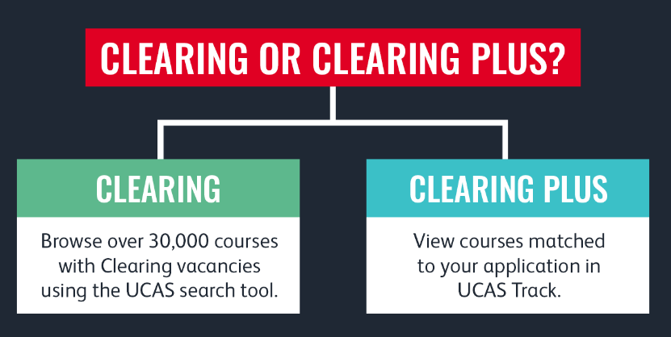

I did not get the grades I wanted:

Hopefully you can still progress onto your next step. You can speak to college/sixth form staff about your grades and there is information about other options, including appeals here.

I have not made any applications:

If you want to go to university, use clearing with information above. If you want to apply to a work-based option, one of our team can help if you contact us and you can also use the resources below to search for vacancies.

Results day: click here for information from UCAS

Conditional offer - if you have applied to university and your offer/s are conditional on your results have your Track login details ready to check the status. There are different possible options depending on your results - find out more.

Unconditional offer - If you're taking exams but have been made an unconditional offer, your results won't affect whether you get accepted. But check the offer to see if there's anything else you need to do. If you change your mind you will need to contact UCAS/university choice directly to be ‘released’ from the course.

Adjustment - If you've met and exceeded conditions for your firm choice, you might be thinking about looking for an alternative course. If you've had a conditional firm choice accepted – and therefore made into an unconditional firm choice – you could potentially swap your place for one on another course you prefer.

Work based opportunity - if you have applied for an apprenticeship or employment and the offer was based on your grades, do contact the company directly for more information. If you have met the grades needed and the company has sent you induction/contract details, do follow up any instructions.

Be prepared!
If you didn’t do as well as expected, it doesn’t mean that you cannot progress. Get support from those around you: school staff, sixth form/college and us at Young WorkPath. You contact us on both results days from 9-12pm and 1-5pm on 0207 364 1401 or 0800 3581 2410 (free phone) or you can email youngworkpath@towerhamlets.gov.uk We expect to be very busy, so please do be patient if contacting us.

Have a fully charged device with phone and Internet access and your UCAS login details (if you’ve applied to university). If you’re going into college/sixth form to collect your results, take your charger/s, notepad and pen. Click here for UCAS contact details.

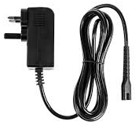
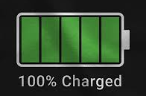

A copy of The Telegraph newspaper (or the online version via your mobile phone) usually lists the places available through Clearing. Many universities already have information on their website and UCAS has a list here.

Resources

Various careers/results day information:

- Young WorkPath www.towerhamlets.gov.uk/careers-service
- UCAS www.ucas.com/
- National Careers Service www.gov.uk/careers-helpline-for-teenagers
- Prospects – results day https://www.prospects.ac.uk/applying-for-university/getting-into-university/what-to-do-on-a-level-results-day
- UCAS - results day https://www.ucas.com/undergraduate/results-confirmation-and-clearing/ucas-undergraduate-results
- BBC Bitesize www.bbc.co.uk/bitesize/articles/z999r2p
- The Uni Guide https://www.theuniguide.co.uk/advice/clearing-results-day/a-level-results-day-grades-what-to-expect
- Careermap https://careermap.co.uk/a-level-results-day-what-you-need-to-know/#:~:text=A%20Level%20Results%20Day%20is%20Tuesday%20the,2021%20in%20England%20and%20Wales.

Apprenticeships (also check company and university websites directly):

- Apprenticeships www.apprenticeships.gov.uk & www.getingofar.gov.uk
- Not Going to Uni https://www.notgoingtouni.co.uk/
- UCAS https://careerfinder.ucas.com/searchjobs/
- Indeed https://www.indeed.co.uk/
- All About School Leavers https://www.allaboutschoolleavers.co.uk/jobs/search/job_type/industry/london/company/1/0/10
- Get My First Job https://www.getmyfirstjob.co.uk/

