If you have Internet Explorer 8 (IE8) and having problems navigating to parts of collect screens or exporting data; you will need to switch to compatibility mode of IE8. If you don’t have access to menus or options mentioned in this guidance then contact your IT support staff to carry out the tasks.

Navigate to Collect login page and click on “compatibility view” button

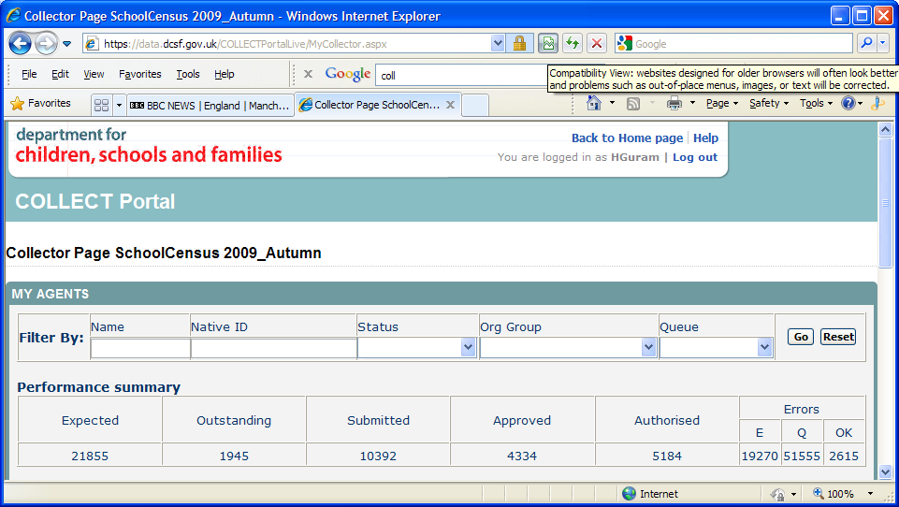
Compatibility view button

After you have clicked on the compatibility view button IE8 will confirm this via a pop up message as shown in screen-print below.

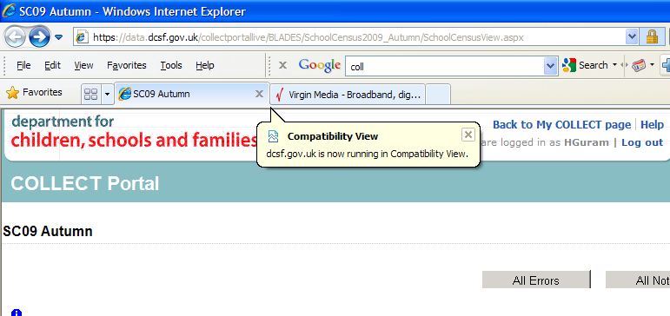

If you don’t have the compatibility view button available; you can enable compatibility view from Tools menu. To do so click on “Tools” and select “Compatibility View” option from the available options.
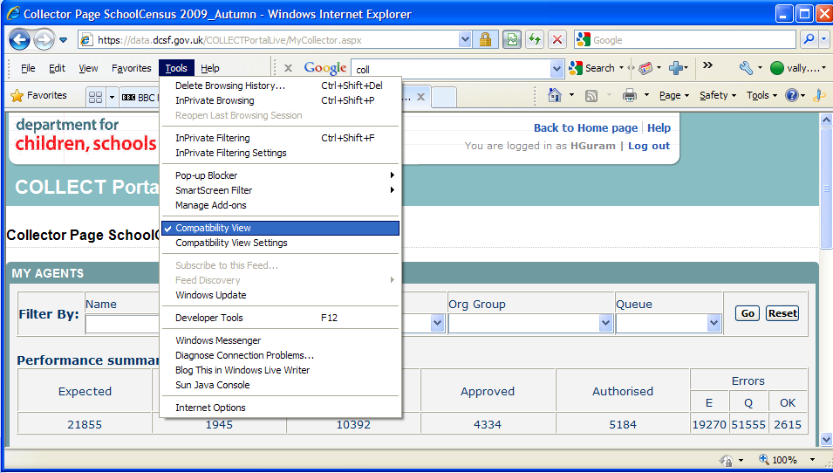

Depending upon your IE8 and security configuration you may have to perform above mentioned action each time. To avoid this, you may want to run IE8 in compatible mode permanently. If you would like to run IE8 in compatible mode for all sites and avoid performing above action each time; then follow the steps below:

Click on “Tools” Menu and select “Compatibility View Settings” option
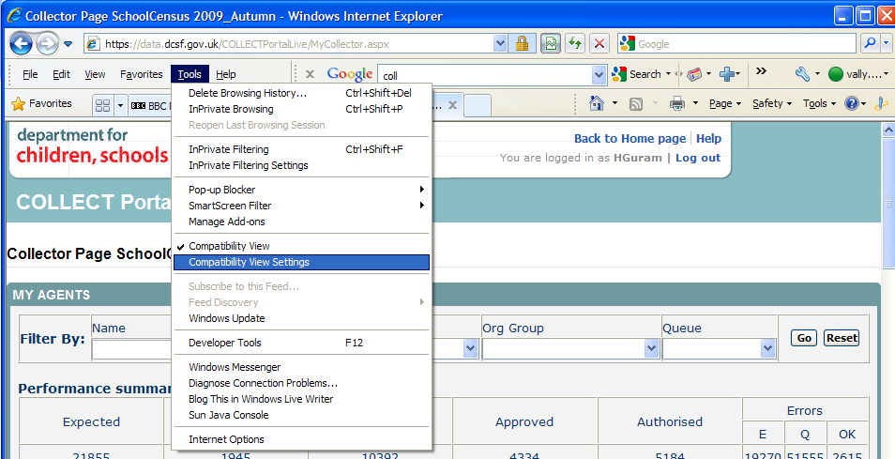

This will open a dialogue window, see screen print below. Now tick the last option box, “Display all websites in compatibility view” and click “Close”.

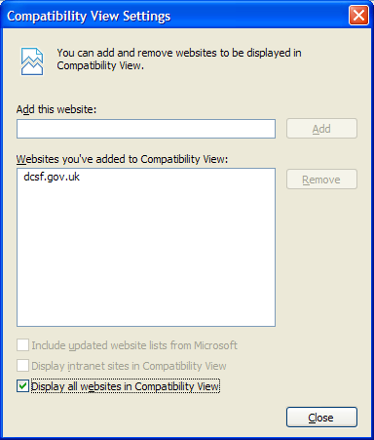

If you still have issues exporting your data from Collect then you will need to add Collect URL to trusted sites and lower the security settings foe trusted sites, to Medium-Low or Low. Follow this link (Microsoft site) http://technet.microsoft.com/en-us/library/dd883248(WS.10).aspx#addinternetsites for instruction on how to add a site to trusted sites. Then apply the settings below from “Tools” >> Internet Options” which will open a window, see screenshot below.

