Resolving issues with School Census returns
Summer School Census 2023

18/05/2023

Table of Contents

Tips to avoid the most common issues experienced by schools 3
Overview 3
Resolving all errors 3
Return level notes 3
School summary 3
Submitting the return 3
Running COLLECT reports 3
Adding notes to errors and queries in your return 4
Reviewing the errors and queries in your return 4
Requirements for notes for common queries 5
‘Admission appeals’ and ‘no classes’ type queries 5
Queries relating to percentages above or below a threshold 5
Pupil’s NC Actual year group not corresponding to their age 5

Tips to avoid the most common issues experienced by schools

Overview
This section sets out the key steps that schools should take to avoid the most common issues with School Census returns.

Resolving all errors
Once a school’s return is shown as “loaded and validated” the school should use the ‘All Errors’ list in COLLECT to review all the errors and queries which have been generated. This step needs to be done even if your Management Information System (MIS) did not show any errors or queries, see the separate section on this within this guidance.
Schools must fix, in their MIS, any data issues identified in that list, then regenerate their return. This corrected version then needs to be uploaded into COLLECT.

Return level notes
Once all errors have been fixed, and queries have been fixed where necessary, seen in the COLLECT ‘All Errors list’, schools must load an adequate ‘return-level’ note. This should be one note that explains all the remaining unresolvable queries as shown on the ‘All Errors list’. The explanation for each unresolvable query should start on a new line, please ensure you include the query code at the beginning of the line.
If you reupload your data to COLLECT a new ‘return-level’ note will need to be added. Old notes can remain, as there is no way to delete them.
When adding the ‘return-level’ note, in COLLECT, please ensure you press the button to ‘Create Note’ to save what you have typed or pasted into the note box.

School summary
Once all errors and queries have been resolved schools should generate the ‘School Summary’ report for the Census from their MIS. Schools must check figures shown in all the tables in this report are accurate, and are as the school would expect, with the Head Teacher, since school funding can be affected if a school’s Census data is inaccurate or incomplete.

Submitting the return
Once the return has been signed off schools must use the ‘Submit Return’ button on COLLECT to submit their return. Unless this is done to sign off the return, the return is not available to the LA to approve for the DfE and the LA cannot fix any duplicates.

Running COLLECT reports
Most reports on COLLECT only refresh overnight. Therefore, schools should run their COLLECT reports the day after they have either made changes to their return or uploaded it. The DfE guidance https://www.gov.uk/guidance/complete-the-school-census/check-your-data explains how to check your data using these reports.
If there are issues with the figures in your funding reports, please check the DfE advice about that Collect report and for the relevant data item(s) first. If this advice does not help you to fix your issue, please contact the LA’s Schools Finance Team.
Duplicate pupil and duplicate UPN reports should be run on the first workday immediately after the 16 June, please re-run these two COLLECT "school duplicates" returns resolving any shown with the other school in your MIS and by editing the appropriate school's existing return in Collect, to be resolved and (so no longer in the COLLECT report) no later than 21 June. Please re-check both those 'school duplicates' reports, once empty, once a week, for 3 more weeks, to ensure they remain empty.

This is because additional duplicates will be identified within COLLECT as other schools upload and make changes to their returns. Schools need to liaise with the other school(s) named for each duplicate to agree the situation, before making any required changes to their MIS. Unlike other errors we recommend that you contact Erica Howlett (020 7364 3361) to resolve the duplicate issues in your return on your behalf. This is because creating and uploading a new return to fix duplicate cases can cause additional errors and queries in COLLECT. Please ensure you contact Erica early in June so there is adequate time for your duplicates to be resolved.

Resolving all errors and queries in your return

Reviewing the errors and queries in your return
The first step is to ‘open’ your return on COLLECT. To do this press the ‘open return’ button, this opens the first screen of the data return which is the ‘return-level’ area of your data return.
We recommend you ignore the table which appears to show how many errors (E) and queries (Q) are in the return as these figures often do not give the true total numbers. Instead open the ‘All Errors’ list which provides an accurate list of all the issues you need to address.
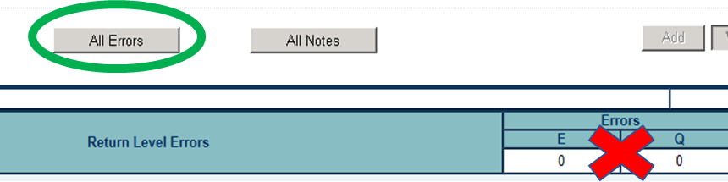
Please note that you should always review the All Errors list, even if no errors or queries were shown in your MIS as it is still possible that errors or queries have been generated by COLLECT.
You can also view the list of errors in your return through the COLLECT ‘Error’ report, which allows you to print the full list. However, this report does not contain the same level of detail as the ‘All Errors’ table in COLLECT, so we recommend that you use the table to help investigate errors so you more easily find and fix them in your MIS.
We recommend sorting the errors table by the error code, to get all errors and queries of the same type into a single group within the ‘All Errors’ table. Please note that the table may have multiple pages, only ten errors or queries are shown per page.
You should use the ‘details’ button (given on relevant lines of the errors table), then click on one of the blue links (which that details button reveals), to view which record is affected by the particular error or query.
To return to the Errors table after viewing an individual record use the ‘Error’ button at the top-right of the screen. Be aware that your ‘sorting order’ of the errors table might need to be re-applied.

How to add a return level note
To do this use the ‘open return’ button to open the first screen of the data return which is the ‘return-level’ area of your data return. A return level note can be added by selecting the pencil symbol button at the top right of the screen. Once a note has been added this will change to a note symbol. You can click on this to add a new return level note.

Requirements for notes for common queries

‘Admission appeals’ and ‘no classes’ type queries (Spring Only)
Notes need to be added when these queries appear, even if the data you have provided is correct. For example, if you had no appeals, please confirm this by adding a supporting note for each of the queries you have remaining, for example:
For the three queries:
‘564Q – school has checked and confirm, there were no Primary admission appeals.’
‘566Q – checked and confirm, there were no Infant admission appeals.’
‘1270Q - we have no (add the year group in query detail) class because… (and then add the relevant explanation).

Queries relating to percentages above or below a threshold
COLLECT will often generate a query where percentages calculated from the data are above or below an in-built threshold, for example where the data suggests an unusually high take up on infant school lunches.
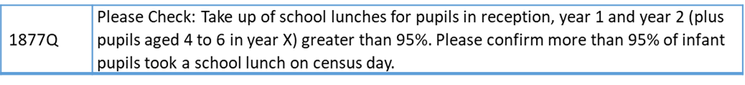
If the data is accurate a note needs to be added. Please try to reiterate as much of the text in the query back into your response, when you add your note, For example:
‘1877Q – Checked and correct: school confirms that more than 95% of pupils in reception, year 1 and year 2 took school lunch on census day.’
Please ensure that you use the same percentage figure (and the same ‘more’ than or ‘less’ than comparator), in your note, as is seen in the query. Please do not use another figure that is relevant for your school.

Pupil’s NC Actual year group not corresponding to their age
There are two possible causes for COLLECT querying that a pupil’s NC actual year group does not correspond to their age. Often it occurs where either a pupil’s year group or date of birth is incorrect, in which case the data needs to be amended in the MIS and in the return. However, it can also occur where a pupil has been kept back a year or is a year ahead. In these instances, a note needs to be entered on to COLLECT, for example ‘2030q –confirm that this pupil was kept behind / leapt ahead a year and that year group and date of birth is confirmed as checked and correct’.

