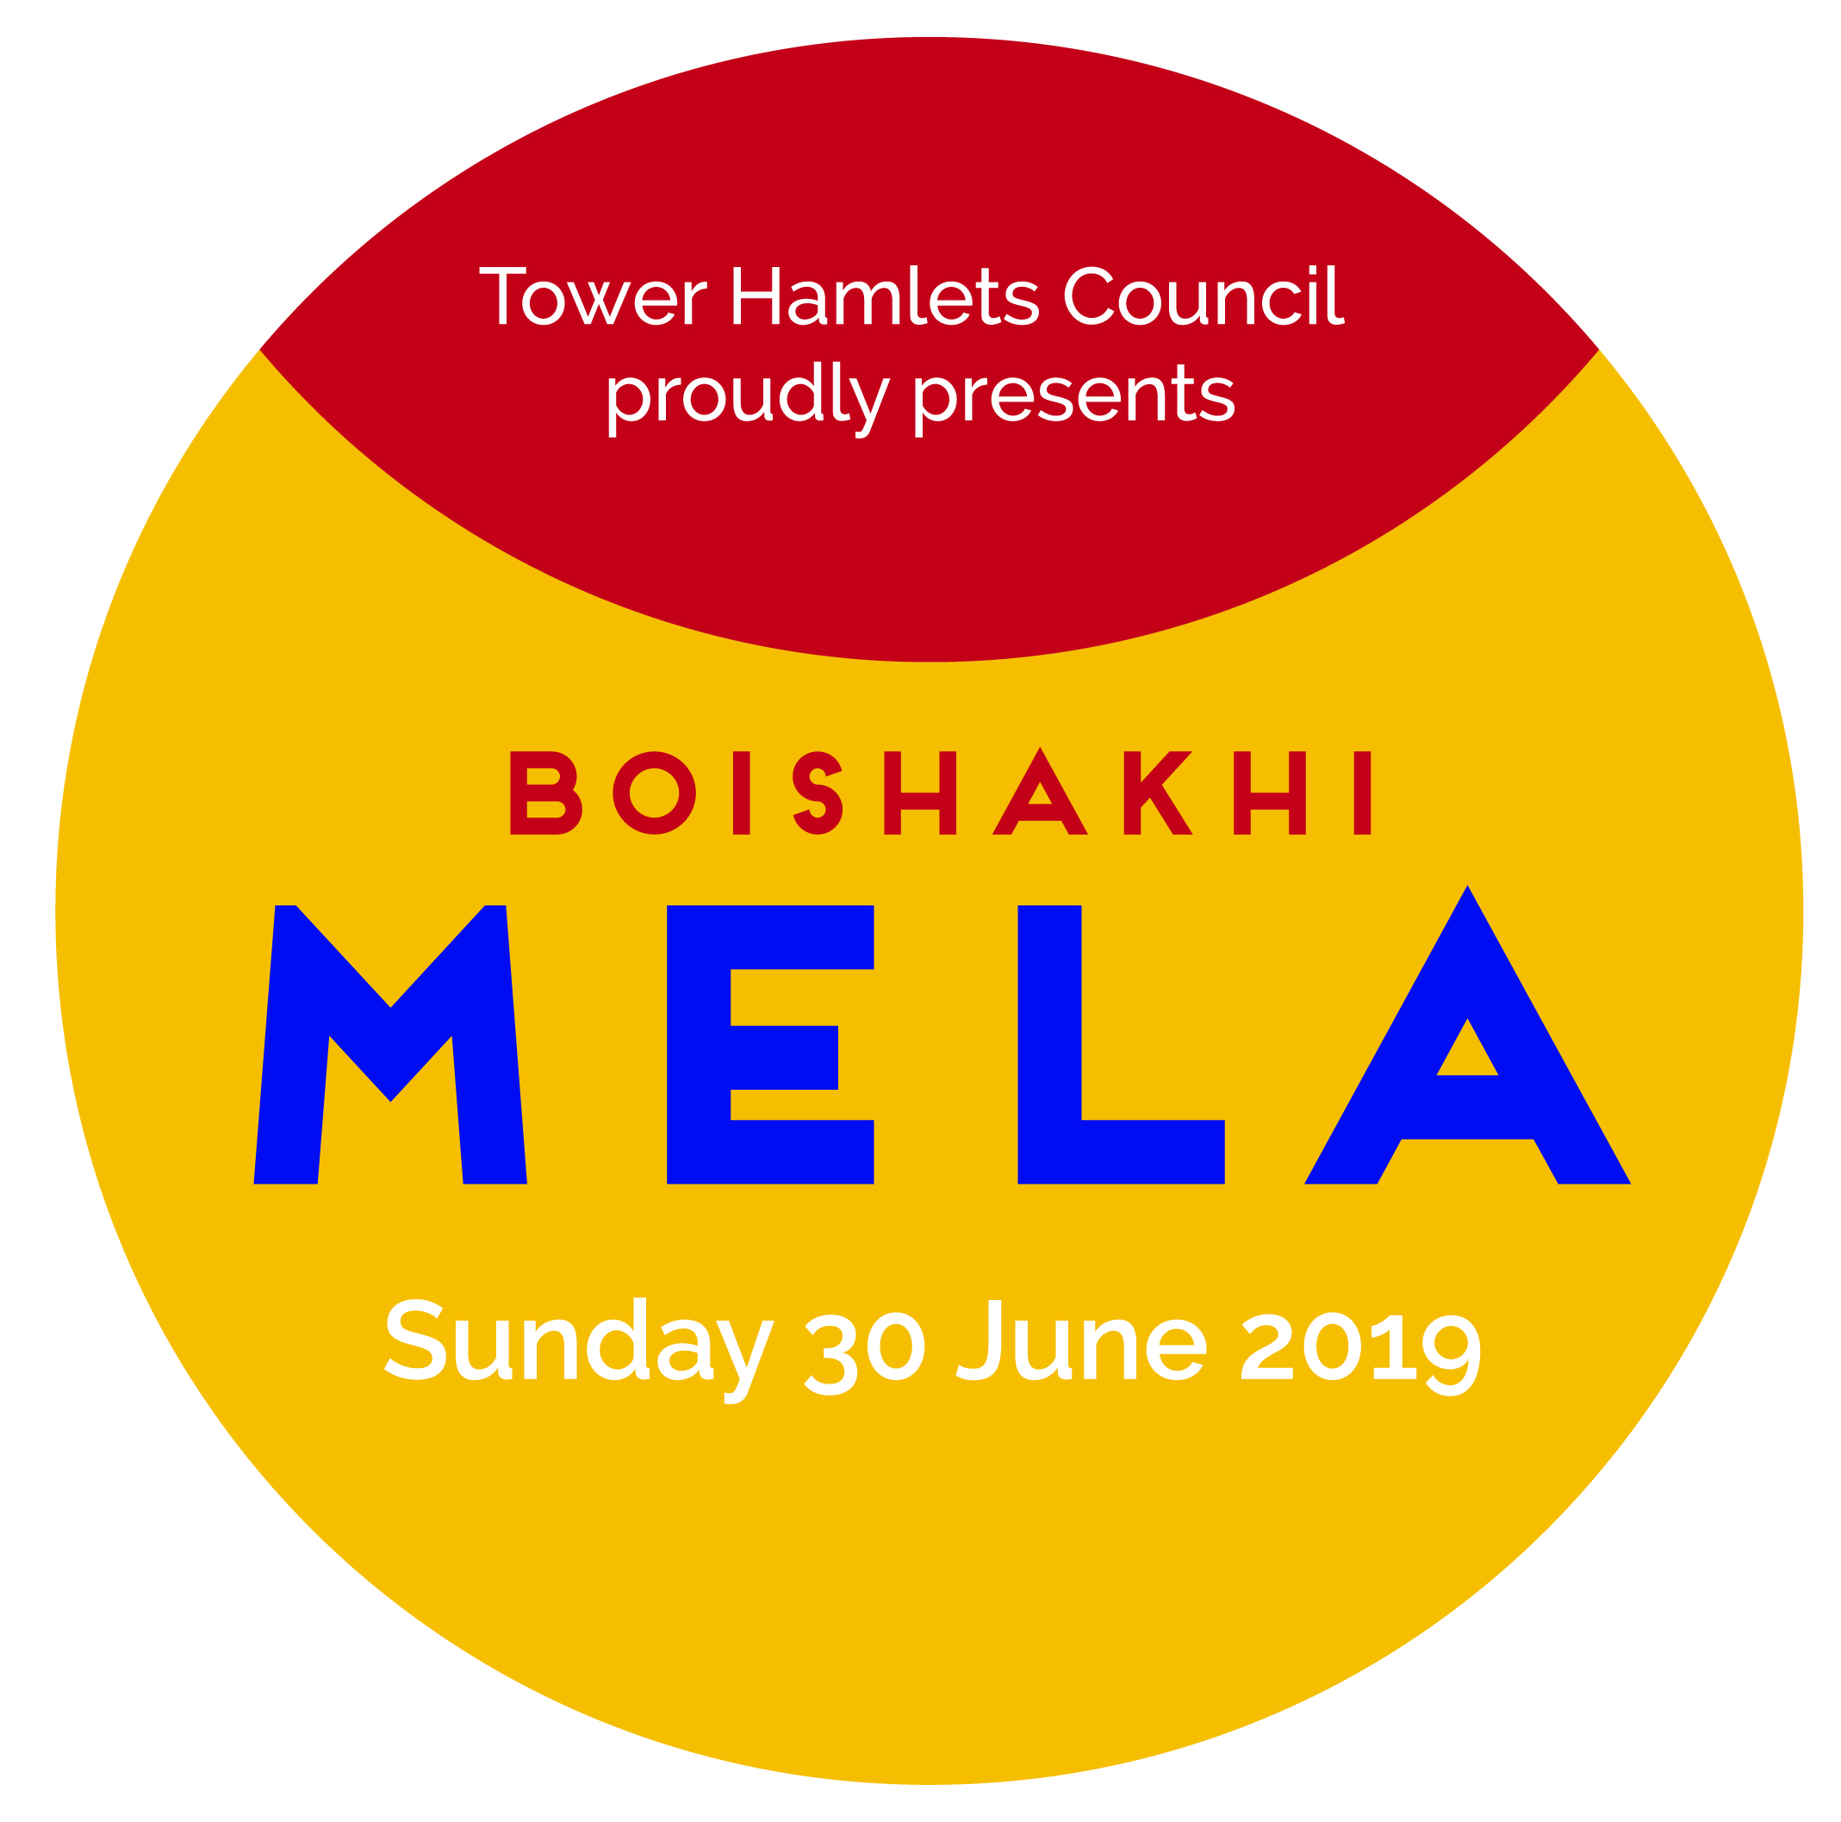
Please read all terms and conditions in full prior to completing your booking form
General Terms & Conditions of Trading:
- Stalls/Marquees are hired at a cost to the Council and if damaged we will be charged. Do not attach any signs / branding in a way that damages the stall/marquee or its roof. Stall holders will be charged for any damage caused.
- The Council reserves the right to allocate stalls at their own discretion.
- All stall holders/traders must comply with the requirements of Trading Standards. Copies of Trading Standards leaflets are available on request.
- Stall holders/traders must NOT sub-let any part of their stall or trading pitch.
- CANCELLATION FEES:
- If you wish to cancel your stall booking you must do so by emailing melatrading@towerhamlets.gov.uk by 12noon on Friday 31 May 2019;
- Cancellations received after 12noon on Friday 31 May 2019 or non-attendance at the event will incur the full booking charge;
- Email: melatrading@towerhamlets.gov.uk or phone: (0207 364 7926 – 10:00am-1:00pm Mon-Fri ONLY) for further details.
- The following items will not be permitted:
- Drinks in glass bottles; alcohol; tobacco, shisha and paan; ice-cream or kulfi; helium balloons; plastics likely to shatter; weapons, potential weapons or replicas; livestock; racist, pornographic or otherwise offensive material; political activity; PA equipment or amplified music without prior permission; any illegal or controlled goods or substances.
- All stall holders/traders are responsible for their own employer’s liability and public liability insurance.
- Stall holders/traders must keep the area surrounding their pitch free of litter. All litter must be bagged and disposed of correctly. Waste disposal facilities will be provided on site.
- Vehicles will be restricted to one per stall within specified times only. There is no on-site parking, we will operate a “drop and go” vehicle system and there is no parking in the immediate area. All stall holders/traders must have a minimum of 2 persons with their vehicle so that the driver can leave site immediately after unloading and the remaining person/s can take responsibility for minding their stock and equipment.
- No generators or LPG are to be brought onto site.
- No activity of any nature, including distribution of literature or selling, may take place outside the limits of your stall.
- Stall holders/traders must be set up and be ready to trade at least one hour before the event opening time.
- Any special requirements should be submitted in writing and sent with your booking form by the booking deadline of 12noon on 31 May 2019.
- The Council has the authority to close down any stall that does not conform to the event regulations.
- Stall holders/traders will not be able to restock during the event – i.e. leave the site by vehicle and come back again.
- Should any stall holder/trader fail to meet safety requirements the Council may need to close your stall.
- Stall holders/traders are not permitted to bring any PA systems to site or to play any amplified music.
- The Council will remove any part of the display or stock outside the limits of a stall holder/trader’s allocated space and may further restrict the display or other equipment should it be a nuisance to other exhibitors or the visiting public. Please do not put stock or equipment in the area behind your stand as this an obstruction and a tripping hazard and prevents other traders from trading.
- Stall holders/traders must comply with directions from the Trader Management Team which will be in line with the Terms & Conditions listed in this booking form; failure to comply with the Trader Management Team may affect requests to trade at future Council events.
- Trading times are from 12noon until 6:45pm.

Additional Terms & Conditions of Trading – High Risk Food Zone:

- ENVIRONMENTAL PROTECTION: We require all traders to supply recyclable materials to the public - e.g. paper plates, wooden cutlery. Please do not bring any plastic materials that may shatter and leave debris that will damage the parks. Mela Trading Area Managers will reserve the right to remove from traders any materials supplied to the public that are likely to cause damage and traders will not be compensated for any resulting loss.
- Any damage to your marquee will result in the loss of your deposit.
- Applications to trade High Risk or Low Risk food are subject to approval by the Tower Hamlets Food Safety Team.
- All food is to be clearly priced and where sold by weight or number, the unit is to be clearly stated.
- CANCELLATION FEES: High Risk traders must provide copies of Public Liability Insurance & Food Hygiene certificates in advance of the event; failure to do so will result in your stall being cancelled and you will incur the full booking charge.
- Food hygiene regulations must be adhered to at all times. All High Risk food traders must attend a compulsory trader training session. (See details on booking form).
- Should any trader fail to meet food hygiene requirements, we may need to close your stall and remove any food products – for which you will not be refunded.
- Failure to stop trading at 6:45pm will result in your bond being withheld.
Additional Terms & Conditions of Trading – Low Risk Food Zone:

- ENVIRONMENTAL PROTECTION: We require all traders to supply recyclable materials to the public - e.g. paper plates, wooden cutlery. Please do not bring any plastic materials that may shatter and leave debris that will damage the parks. Mela Trading Area Managers will reserve the right to remove from traders any materials supplied to the public that are likely to cause damage and traders will not be compensated for any resulting loss.
- Applications to trade High Risk or Low Risk food are subject to approval by the Tower Hamlets Food Safety Team.
- All food is to be clearly priced and where sold by weight or number, the unit is to be clearly stated.
- CANCELLATION FEES: Low Risk food traders must provide a copy of their Public Liability Insurance certificate in advance of the event; failure to do so will result in your stall being cancelled and you will incur the full booking charge;
- Food hygiene regulations must be adhered to at all times.
- Should any trader fail to meet food hygiene requirements, we may need to close your stall and remove any food products – for which you will not be refunded.

Additional Terms & Conditions of Trading – Crafts & Goods (Non-Food):
- Should any trader fail to meet safety requirements, we may need to close your stall and remove any products – for which you will not be refunded.
- Toys must be ‘CE’ marked.
- Textiles and shoes must have textile labels.
- New electrical devices must be ‘CE’ marked and be sold with a UK plug.

Additional Terms & Conditions of Trading – Registered Charities:
- Charities must provide proof of charity status and will be accepted only if appropriate to the event.

